

INSTITUTE FOR ADVANCED COMPUTING AND

SOFTWARE DEVELOPMENT AKURDI, PUNE

Documentation On

**“ CAR Rental System ”**

PG-DAC SEPT 2022

**Submitted By:**

**Group No: 11**

|  |  |
| --- | --- |
| **Roll No.** | **Name:** |
| **229015** | **Ayush Upadhyay** |
| **229032** | **Prakash Ghadage** |
| **Mr. Rohit Puranik** | **Miss.Sonali Mogul** |
| **Centre Coordinator** | **Project Guide** |

## ABSTRACT

The car rental system project is an online platform designed to provide an efficient and user-friendly experience for car rental services. The system allows customers to browse and book rental cars based on their preferences, such as car type, location, and rental duration. The platform also provides an easy-to-use dashboard for rental companies to manage their fleet, bookings, and customer interactions. The system includes various features, such as secure online payments, real-time availability of vehicles, and a rating system for customers to provide feedback on their rental experience. The car rental system aims to streamline the process of car rental services and provide an enjoyable experience for customers while increasing the efficiency and profitability of rental companies

## ACKNOWLEDGEMENT

I take this occasion to thank God, almighty for blessing us with his

grace and taking our endeavor to a successful culmination. I extend my sincere and heartfelt thanks to our esteemed guide, **Miss.Sonali mogul** for providing me with the right guidance and advice at the crucial juncture sand for showing me the right way. I extend my sincere thanks to our respected **Centre Co-Ordinator Mr. Rohit Puranik**, for allowing us to use the facilities available. I would like to thank the other faculty members also, at this occasion. Last but not the least, I would like to thank my friends and family for the support and encouragement they have given me during the course of our work.

**Ayush Upadhyay (229032)**

**Prakash Ghadage (219156)**

**Table of Contents**

ABSTRACT 2

ACKNOWLEDGEMENT 3

INTRODUCTION 7

FEATURES 7

1.1 PROJECT OBJECTIVE 8

1.2 PROJECT OVERVIEW 8

1.3 PROJECT SCOPE 9

1.4 STUDY OF THE SYSTEM 9

1.4.1 MODULES 9

SYSTEM ANALYSIS 19

2.3 SYSTEM REQUIREMENT SPECIFICATION 19

2.3.1OBJECTIVES 19

2.3.2 SCOPE 19

2.3.3 DEFINATION 19

2.3.4 SYSTEM REQUIREMENTS 20

MODERATOR 23

DESCRIPTION OF FEATURES 23

ADMIN 23

SYSTEM DESIGN 25

3.1 INPUT AND OUTPUT DESIGN 25

3.1.1 INPUT DESIGN 25

3.1.2 OUTPUT DESIGN 25

DATABASE DESIGN 27

3.2 DATABASE 27

3.3 SYSTEM TOOLS 27

3.3.1 FRONT END 27

3.3.2 BACKEND 27

1 LEVEL DFD FOR ADMIN 28

1 LEVEL DFD FOR CUSTOMER 29

E-R DIAGRAM 30

USE CASE DIAGRAM 31

TABLE STRUCTURE 32

PROJECT DIAGRAMS 37

CONCLUSION 54

REFERENCES 55

**LIST OF FIGURES**

**FIGURE 1: DFD DIAGRAM ------------------------------------------------------------ 11**

**FIGURE 2: E-R DIAGRAM ---------------------------------------------------------------- 30**

**FIGURE 3: USE CASE DIAGRAM -------------------------------------------------------- 13**

**FIGURE 4: CLASS DIAGRAM ------------------------------------------------------------ 31**

**FIGURE 5: TABLE STRUCTURE -------------------------------------------------------- 32**

**FIGURE 6: PROJECT DIAGRAMS---------------------------------------------------- 37**

## INTRODUCTION

The car rental system is an online platform designed to provide customers with an easy and efficient way to rent cars for personal or business use. The system is developed to automate and streamline the traditional car rental process, making it more convenient, time-efficient, and cost-effective for both customers and rental companies.

The car rental system is a web-based application that allows customers to browse and book rental cars based on their preferences, such as car type, location, rental duration, and price range. The system provides a user-friendly interface that allows customers to search for available cars, view car details, compare prices, and make bookings in just a few clicks.

The car rental system is an excellent solution for customers who need to rent cars for short or long periods, such as tourists, business travelers, or individuals with temporary transportation needs. It also offers significant benefits for rental companies, including increased efficiency, reduced costs, and improved customer satisfaction.

In this documentation, we will provide a detailed overview of the car rental system, its features, functionalities, and benefits. We will also discuss the technical aspects of the system, including the development platform, architecture, and database design.

## 

## Features: -

1. Car Inventory Management: The car rental system allows rental companies to manage their car inventory efficiently. The rental company can add or remove cars from the system, set rental rates, and update car details, such as make, model, and mileage.
2. Online Booking and Payment: The car rental system provides a user-friendly interface for customers to search for available cars, view car details, and make bookings online. The system also allows customers to pay for their bookings securely using credit/debit cards or other online payment methods.
3. Real-time Availability: The system provides real-time data on car availability, allowing customers to view the latest information on car availability and make bookings accordingly.
4. Rental Duration and Pricing: The system allows customers to select their rental duration and view the rental price based on the rental period. The rental company can set different rental rates for different car types, rental periods, and locations.
5. Customer Profile Management: The system allows customers to create and manage their profiles, including personal information, contact details, and booking history. This feature enables customers to save time by quickly accessing their booking history and preferences.
6. Rating and Review System: The system provides a rating and review system that allows customers to rate their rental experience and provide feedback on the service quality. This feature helps rental companies to improve their service quality and increase customer satisfaction.
7. Reports and Analytics: The system provides reports and analytics that allow rental companies to track their business performance, including car utilization, revenue, and customer feedback.

## 

## 1.1 PROJECT OBJECTIVE

The primary objective of the car rental system project is to provide an efficient and user-friendly platform for customers to rent cars and for rental companies to manage their business operations. The project aims to automate and streamline the traditional car rental process, making it more convenient, time-efficient, and cost-effective for both customers and rental companies.

## 1.2 PROJECT OVERVIEW

The car rental system project is an online platform designed to provide customers with a convenient and efficient way to rent cars and for rental companies to manage their business operations. The system is developed using web-based technologies, making it accessible to customers and rental companies from any location.

The car rental system project is built around a database-driven architecture, where all data related to car inventory, bookings, payments, and customer profiles are stored in a centralized database. The system includes various modules, such as a car inventory management module, a booking and payment module, a customer profile management module, and a rating and review module.

The car rental system project allows customers to browse available cars based on their preferences, such as car type, location, and rental duration. Customers can view car details, compare prices, and make bookings online. The system provides real-time data on car availability, allowing customers to make bookings based on the latest information.The car rental system project includes a secure online payment system that allows customers to pay for.

The car rental system project aims to provide an end-to-end solution for car rental services, benefiting both customers and rental companies by improving efficiency, reducing costs, and increasing customer satisfaction. The system is designed to be user-friendly, mobile-friendly, and scalable, making it suitable for small to large-scale car rental businesses.

## 1.3 PROJECT SCOPE

The main objective of a Car Rental system is to provide a convenient and efficient way for customers to rent vehicles for short periods of time. The system should be easy to use, secure, and provide a wide range of vehicle options at competitive prices. The system should also facilitate the booking process, manage vehicle inventory, handle customer payments, and ensure the safety and maintenance of the vehicles. Additionally, the system should provide reports and analytics to help the rental company optimize its operations and improve customer satisfaction.

## 1.4 STUDY OF THE SYSTEM

### 1.4.1 MODULES:

1. Reservation Management Module: This module allows customers to make reservations for a car rental online, over the phone or in person. It includes features such as availability checking, booking confirmation, and reservation modification.
2. Inventory Management Module: This module tracks the availability of rental cars and manages the inventory of the rental fleet. It includes features such as car registration, maintenance schedules, and vehicle inspection.
3. Customer Management Module: This module manages customer information, including their rental history, personal details, and payment information. It includes features such as customer registration, identification verification, and customer communication.
4. Payment Management Module: This module handles the payment process for rental cars, including billing, invoicing, and payment tracking. It includes features such as credit card processing, cash handling, and refunds.
5. Reporting and Analytics Module: This module generates reports and provides insights into rental car business performance. It includes features such as revenue tracking, inventory forecasting, and customer analytics.
6. Fleet Management Module: This module manages the rental fleet and ensures that all cars are properly maintained and serviced. It includes features such as maintenance schedules, vehicle tracking, and fuel tracking.

Bottom of Form

## SYSTEM ANALYSIS

Customer demand and preferences: Analyzing customer demand and preferences is important in determining the type of cars to include in the rental fleet and the pricing strategy to adopt. For instance, if customers are interested in eco-friendly cars, the rental business may consider including hybrid or electric cars in the fleet.

Competitive landscape: Evaluating the competition in the car rental market can help a business to identify areas of opportunity and areas where they need to improve. This involves researching the pricing strategy of competitors, the types of cars in their fleet, and their customer service.

Operational efficiency: Analyzing the operational processes of the car rental business can help to identify areas where the business can improve its efficiency. This includes evaluating the rental process from reservation to return, and identifying areas of inefficiency, such as long wait times or complex paperwork.

Fleet management: Managing the rental fleet is a critical aspect of a car rental system analysis. This includes evaluating the age and condition of the cars, fuel efficiency, and maintenance schedules.

Technology: The use of technology in a car rental system can improve the rental experience for customers and increase the efficiency of the business. This includes using online reservation systems, mobile apps for rental management, and GPS tracking for fleet management.

Financial analysis: Analyzing the financial performance of the car rental business is important in identifying areas of profitability and areas where cost savings can be made. This involves evaluating revenue, expenses, and profit margins.

## 2.3 SYSTEM REQUIREMENT SPECIFICATION

**2.3.1 Objective (Purpose):**

Faster Process – To make sure a user gets his desire car as early as possible; the car rental management system will provide a faster response to complete the process.

Minimize paperwork – As all the system is computerized, there is no need to fill any application form for renting purpose. So, the paperwork will be very less.

Centralized – All types of data and the activities related to the system will be kept in a single place so that it is easy to monitor the system and provide the customer the best service.

**2.3.2 Scope:**

The main objective of the Car Rental System is to manage the details of Car, Payment, Customer, Supplier, Category. It manages all the information about Car, Booking, Bill. The project is totally built at administrative end and thus only the administrator is guaranteed the access

**2.3.3 Definitions:**

CRS: Car Rental System

Portal: Personalized Online Web Application

MIS: Management Information System

CRM: Customer Relation Management

BI : Business Intelligence

KPI : Key Performance I

**2.3.4.Functional Requirements:**

Admin:

Admin is basically a superuser. Admin can add a car, manage booking cars, and rent. Admin will keep track of each booking. Manage organization representatives. Admin is responsible for any error in the system. So, he needs to alter at any point in time. Admin should keep tracking car renting service, maintenance of cars.

User:

The user is the end-user of our service. Users can view information of the available car, booking a car, easily get the car on rent, and also give feedback and an inquiry. User also views the discount and other information to get best deals.

**Non-Functional Requirement:**

Non-Functionality such as performance, security, or availability, usually specify or constrain characteristics of the system as a whole.

Usability:

The system provides a help and support menu in all interfaces for the user to interact with the system

Reliability:

The system will backup business data on regular basis and recover in short time duration to keep system operational

Continuous updates are maintained , continuous Administration is done to keep system operational.

During peak hours system will maintain same user experiance by managing load balancing .

Maintainability:

A Commercial database software will be used to maintain System data Persistence.

A readymade Web Server will be installed to host online Car Rental System (Web Site) to management server capabilities.

IT operations team will easily monitor and configure System using Administrative tools provided by Servers.

.

Portability:

PDA: Portable Device Application

System will provide portable User Interface ( HTML, CSS, JS) through users will be able to access Car Rental System.

Accessibility:

only registered customer will be able to place an order after authentication..

Admin will be able to see their Car Rental System bill graph

Durability:

System will retain customer Car Rental System for 15 minutes even though customer loose internet connection and join again.

System will maintain wishlist for customer . customer will be able to Book Car from wishlist and Rent.

System will implement backup and recovery for retaining Car holders data, business operation data and business data over time.

Efficiency:

On Festival season, maximum number of users will Rent Car, view Car.

System will be able to manage all transactions with isolation.

Modularity :

System will designed and developed using reusable, independent or dependent business scenarios in the form of modules.

These modules will be loosely coupled and highly cohesive.

Scalability:

System will be able to provide consistent user experiance to Car Rental Customer as well as visitors irrespective of load.

Safety:

Car Rental System will be secure from malicious attack, fishing.

Car Rental System functionalities are protected from outside with proper firewall configuration.

Business data will be backed up periodically to ensure safety of data using incremental back up strategy.

Role based security will be applied for Application data and operations accessibility.

## MODERATOR

## Description of features

1. Reservation management: A moderator can manage reservations by ensuring that the car rental system accurately reflects the availability of vehicles, confirming reservations, and modifying reservations as necessary.
2. Rental process management: A moderator can manage the rental process by ensuring that the process is streamlined and efficient, providing clear instructions to customers, and ensuring that the rental documents are complete and accurate.
3. Customer support: A moderator can provide customer support by answering questions and addressing concerns related to the car rental system. This includes providing assistance with reservations, rentals, and returns, and handling customer complaints.
4. Fleet management: A moderator can manage the fleet of rental vehicles by monitoring the condition of the vehicles, scheduling maintenance and repairs, and coordinating the purchase or sale of vehicles as needed.
5. Financial management: A moderator can manage the financial aspects of the car rental system by handling payments, monitoring revenue and expenses, and preparing financial reports.
6. Technology management: A moderator can manage the technology used in the car rental system by ensuring that the online reservation system and other technology tools are up to date and functioning properly.

## 

## SYSTEM DESIGN

1. User Interface: The user interface will be the primary interaction point between the customer and the car rental system. The UI will be designed to be intuitive and easy to use, allowing customers to browse the available rental options, make reservations, and manage their rental.
2. Database Management: The car rental system will maintain a database of available vehicles, rental reservations, customer data, and rental history. The database management system will be designed to be efficient and scalable, allowing the system to handle a large number of concurrent users and rental requests.
3. Reservation Management: The reservation management system will allow customers to make reservations for a vehicle at a specific location and time. The system will verify vehicle availability and provide customers with confirmation of their reservation.
4. Rental Management: The rental management system will allow customers to manage their rental, including checking the rental status, modifying their reservation, and extending the rental period. The system will also provide information on the rental terms and conditions, including insurance coverage, mileage limits, and fuel requirements.
5. Payment Management: The payment management system will handle payments from customers for rentals, including accepting credit card payments and processing refunds as necessary. The system will also generate reports and analytics on revenue, expenses, and profit margins.
6. Customer Support: The car rental system will provide customer support through various channels like phone, email, chatbot or a helpdesk. The system will ensure that the customers can get quick and easy support related to reservations, rentals, returns and other queries.
7. Security and Privacy: The car rental system will maintain a high level of security and privacy, protecting customer data and transactions. The system will use encryption, firewalls, and other security measures to ensure the safety of customer information.

## DATABASE DESIGN

## 3.2 DATABASE

Databases are the storehouses of data used in the software systems. The data is stored in tables inside the database. Several tables are created for the manipulation of the data for the system. Two essential settings for a database are

▪ Primary key - the field that is unique for all the record occurrences ▪ Foreign key - the field used to set relation between tables

Normalization is a technique to avoid redundancy in the tables.

## 3.3 SYSTEM TOOLS

The various system tools that have been used in developing both the front end and the back end of the project are being discussed in this chapter.

### 3.3.1 FRONT END:

React is a library which is developed by Facebook are utilized to implement the frontend. React (also known as React.js or ReactJS) is a [free and open-source](https://en.wikipedia.org/wiki/Free_and_open-source_software) [front-end](https://en.wikipedia.org/wiki/Front_end_and_back_end) [JavaScript library](https://en.wikipedia.org/wiki/JavaScript_library) for building [user interfaces o](https://en.wikipedia.org/wiki/User_interfaces)r UI components. It is maintained by [Facebook a](https://en.wikipedia.org/wiki/Facebook%2C_Inc)nd a community of individual developers and companies. React can be used as a base in the development of [single page o](https://en.wikipedia.org/wiki/Single-page_application)r mobile applications. However, React is only concerned with state management and rendering that state to the [DOM,](https://en.wikipedia.org/wiki/Document_Object_Model) so creating React applications usually requires the use of additional libraries for routing, as well as certain client-side functionality.

### 3.3.2 BACKEND:

The back end is implemented using MySQL which is used to design databases.

**MySQL:**

MySQL is the world's second most widely used open-source relational database management system (RDBMS). The SQL phrase stands for Structured Query Language. An application software called Navicert was used to design the tables in MySQL.

**Spring-Boot:**

This is used to connect MYSQL and fetch data from database and store the data in database. The Spring Framework is a[n application framework a](https://en.wikipedia.org/wiki/Application_framework)nd [inversion of control](https://en.wikipedia.org/wiki/Inversion_of_control) [container f](https://en.wikipedia.org/wiki/Servlet_container)or the [Java platform. T](https://en.wikipedia.org/wiki/Java_platform)he framework's core features can be used by any Java application, but there are extensions for building web applications on top of the [Java EE (](https://en.wikipedia.org/wiki/Java_EE)Enterprise Edition) platform. Although the framework does not impose any specific [programming model,](https://en.wikipedia.org/wiki/Programming_model) it has become popular in the Java community as an addition to the [Enterprise JavaBeans (](https://en.wikipedia.org/wiki/Enterprise_JavaBeans)EJB) model. The Spring Framework is Open-source Framework.

# 

# 

DFD Diagram:

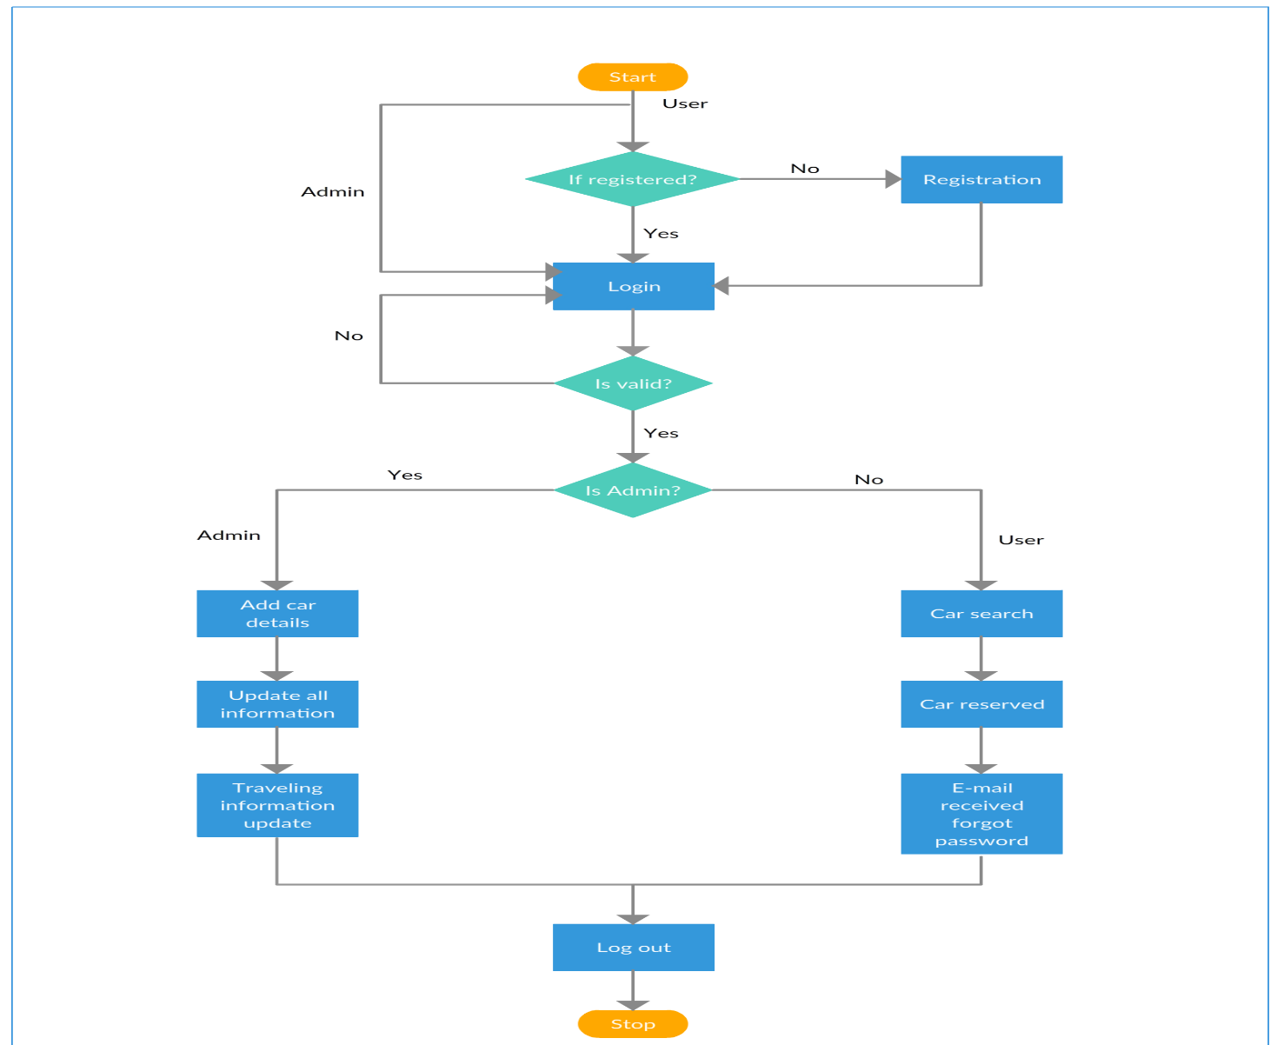

***Figure 1 DFD Diagram***

# E-R Diagram:

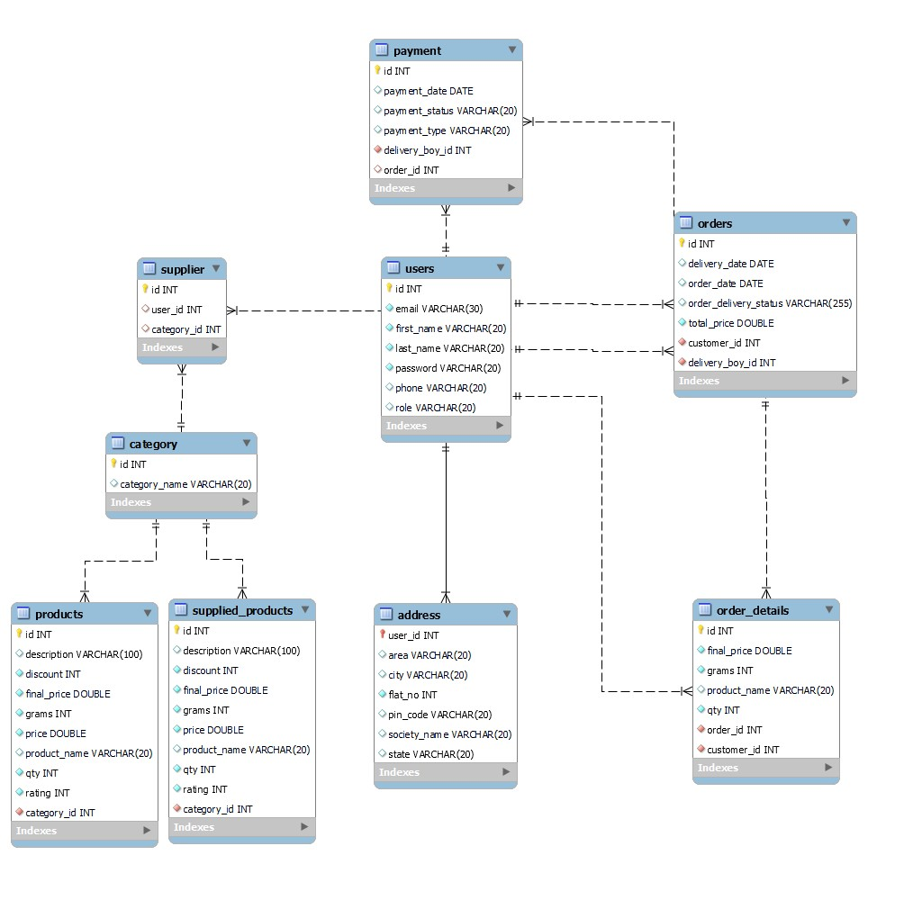

***Figure 2 E-R Diagram***

# Use Case Diagram

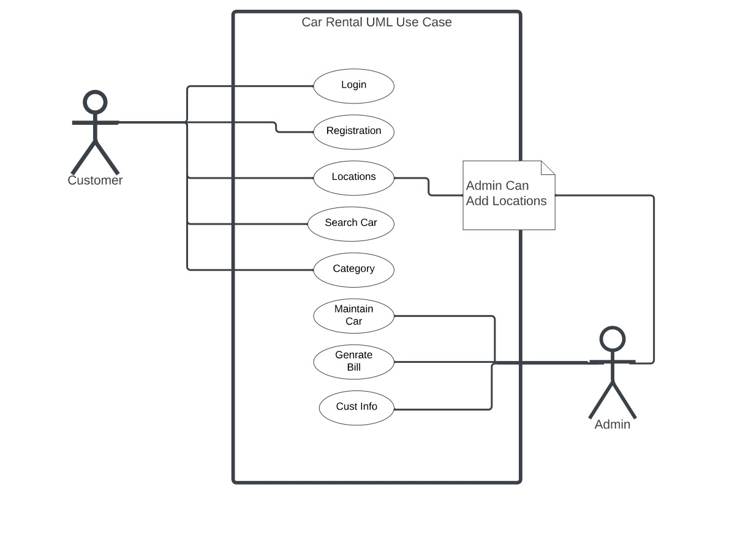

***Figure 3 Use Case Diagram***

# TABLE STRUCTURE:

**Tables:**

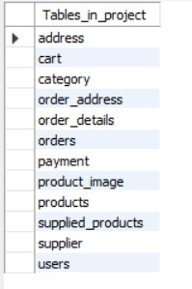

**Address:**

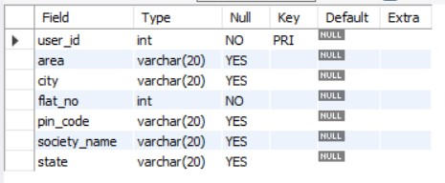

**Cart:**

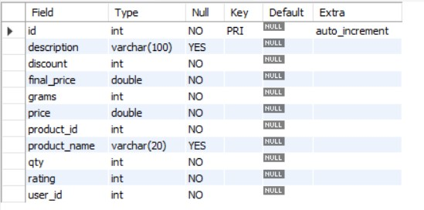

**Category:**

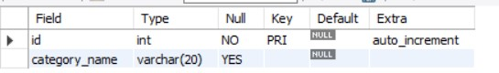

**Order Address:**

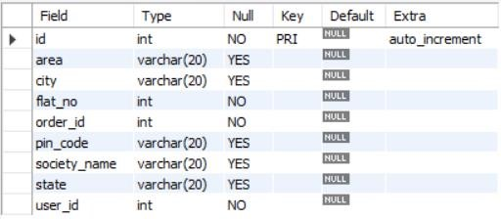

**Order Details:**

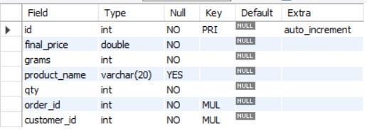

**Orders:**

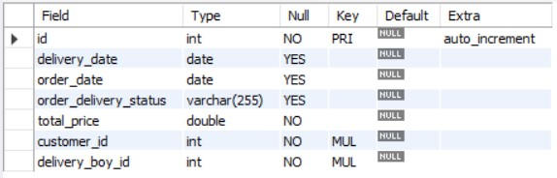

**Products:**

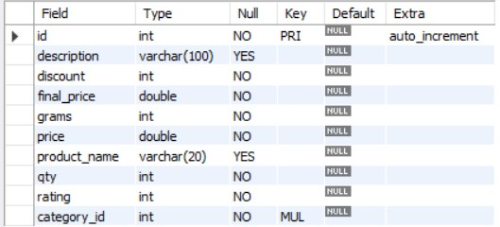

**Product Image:**

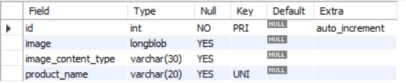

**Payment:**

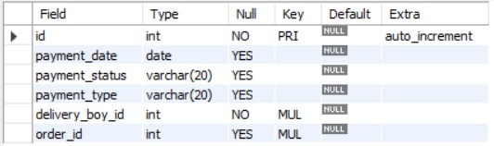

**Supplied Products:**

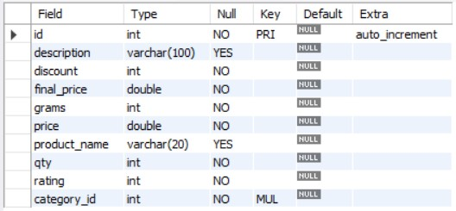

**Supplier:**

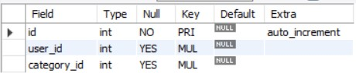

**Users:**

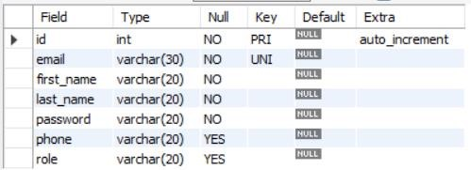

# PROJECT DIAGRAMS

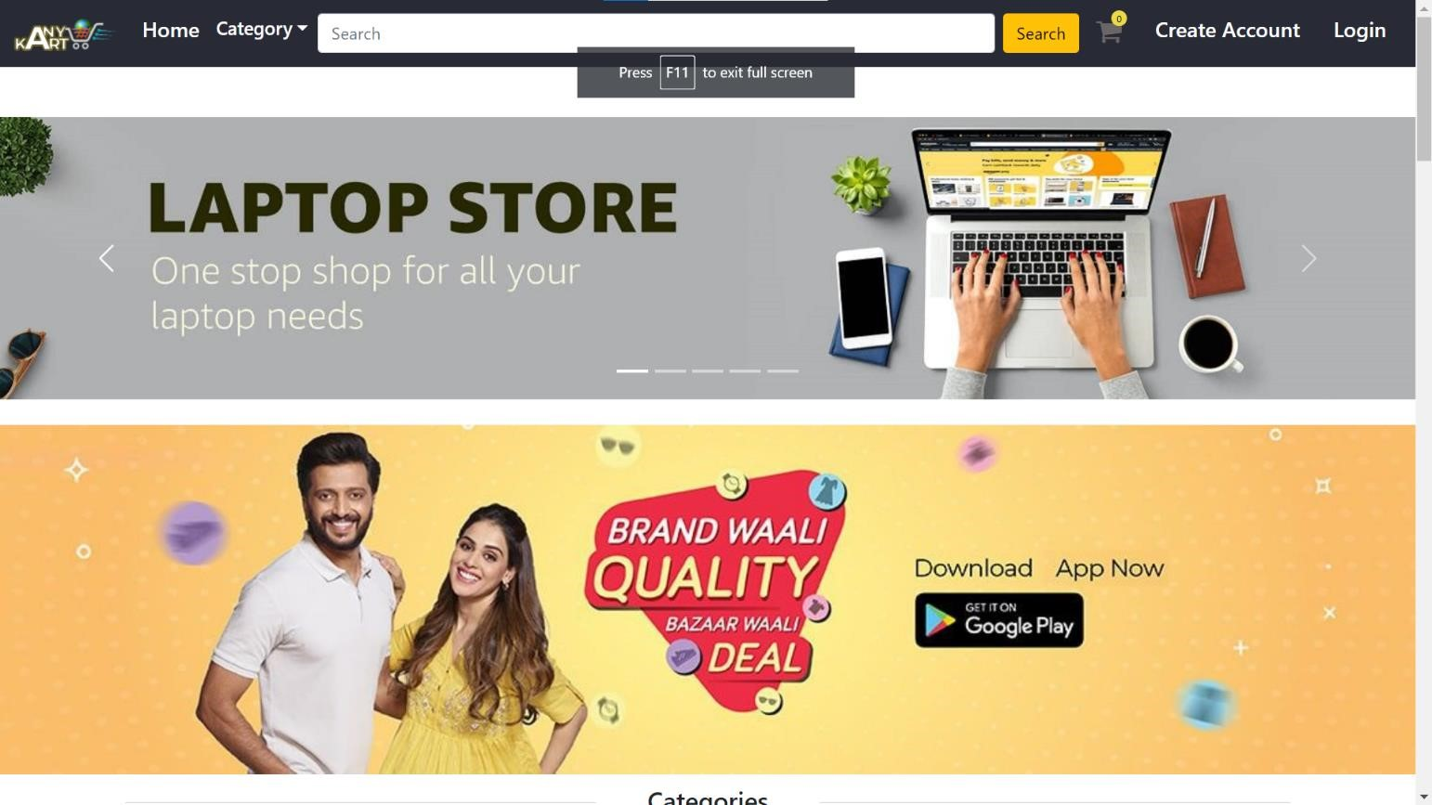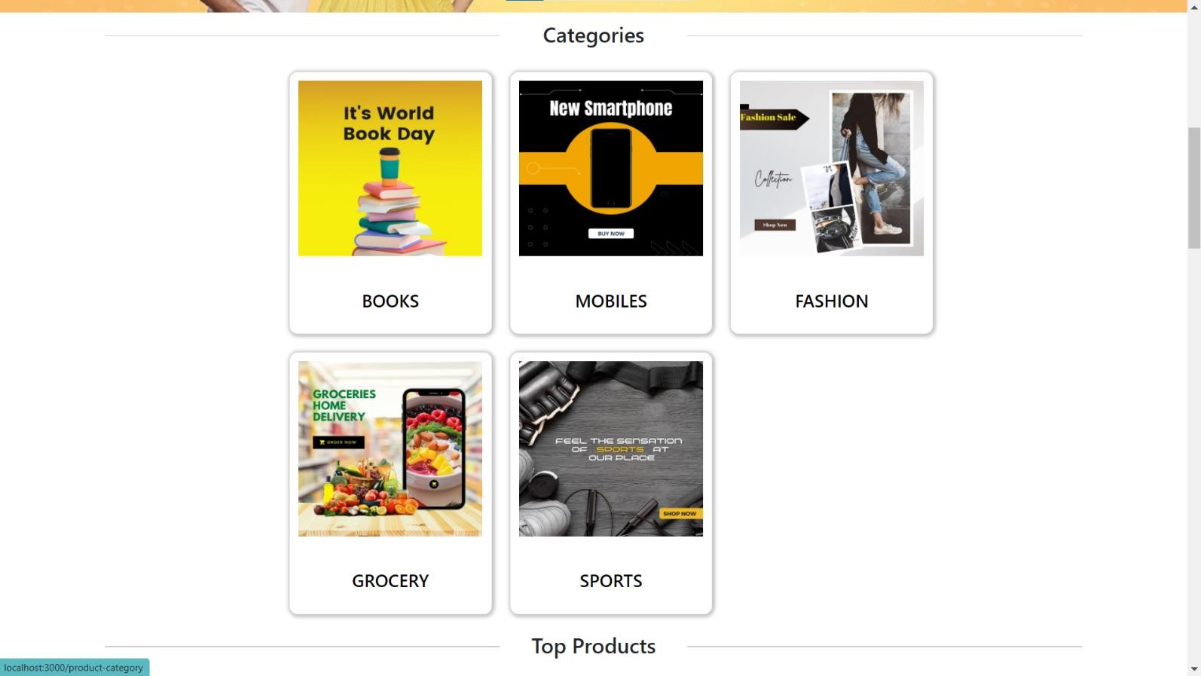

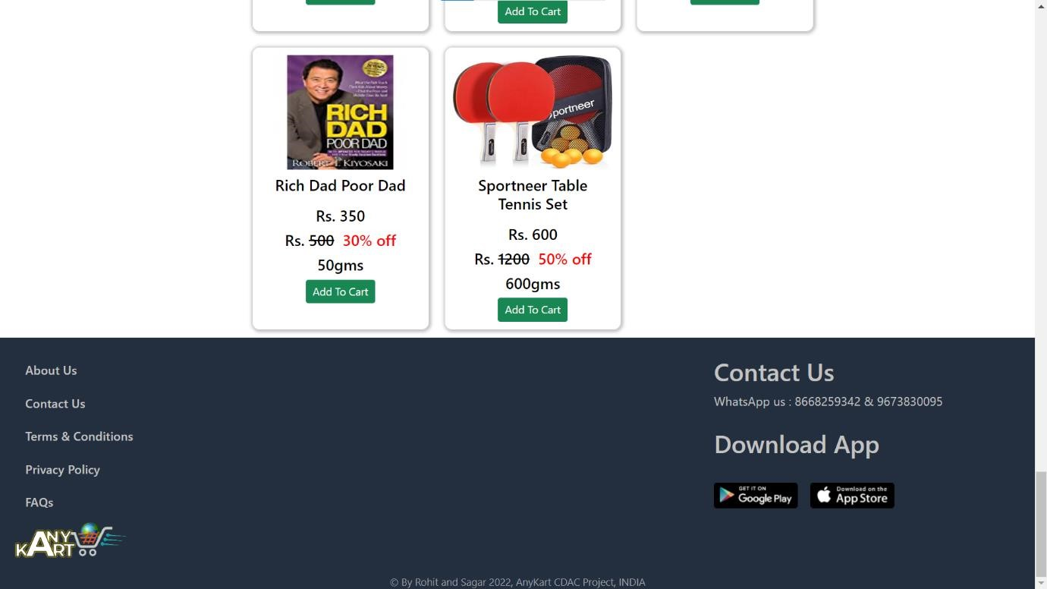

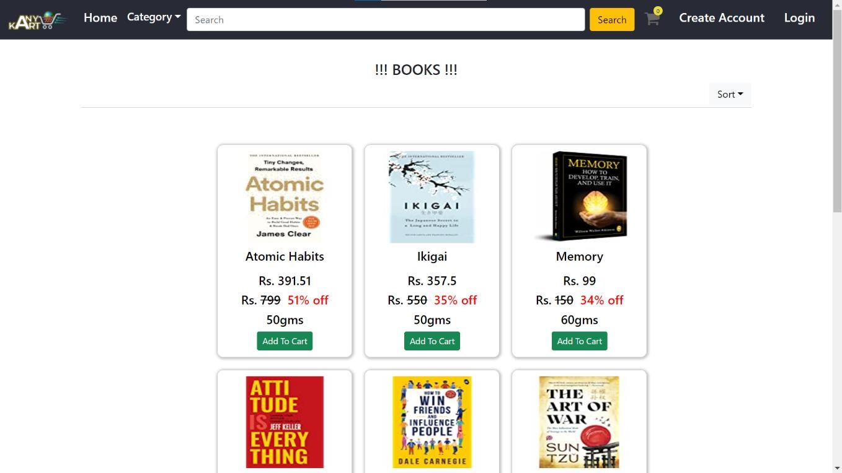

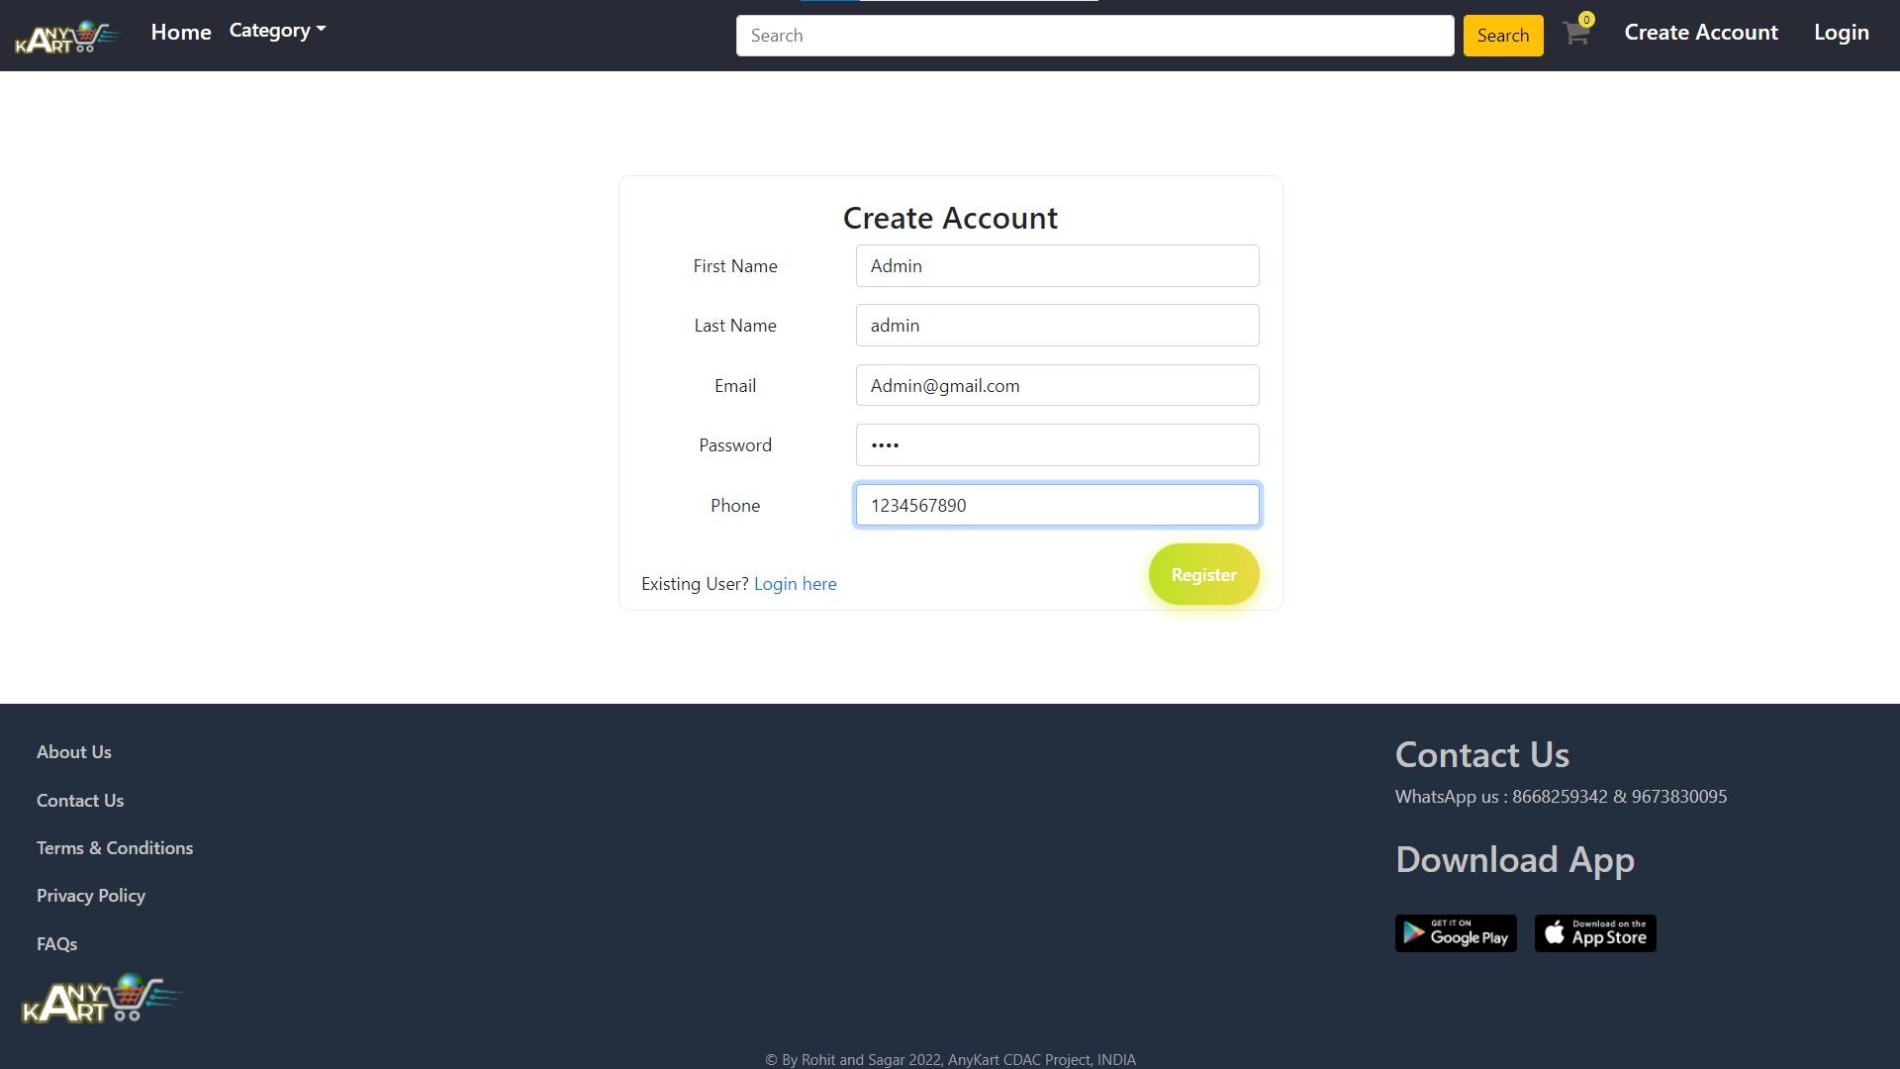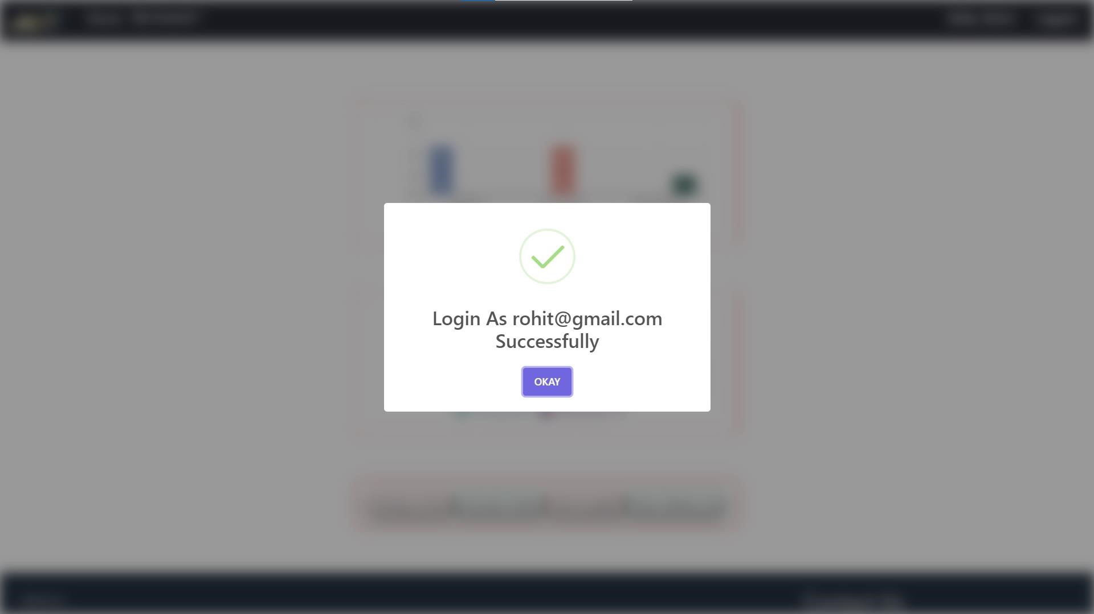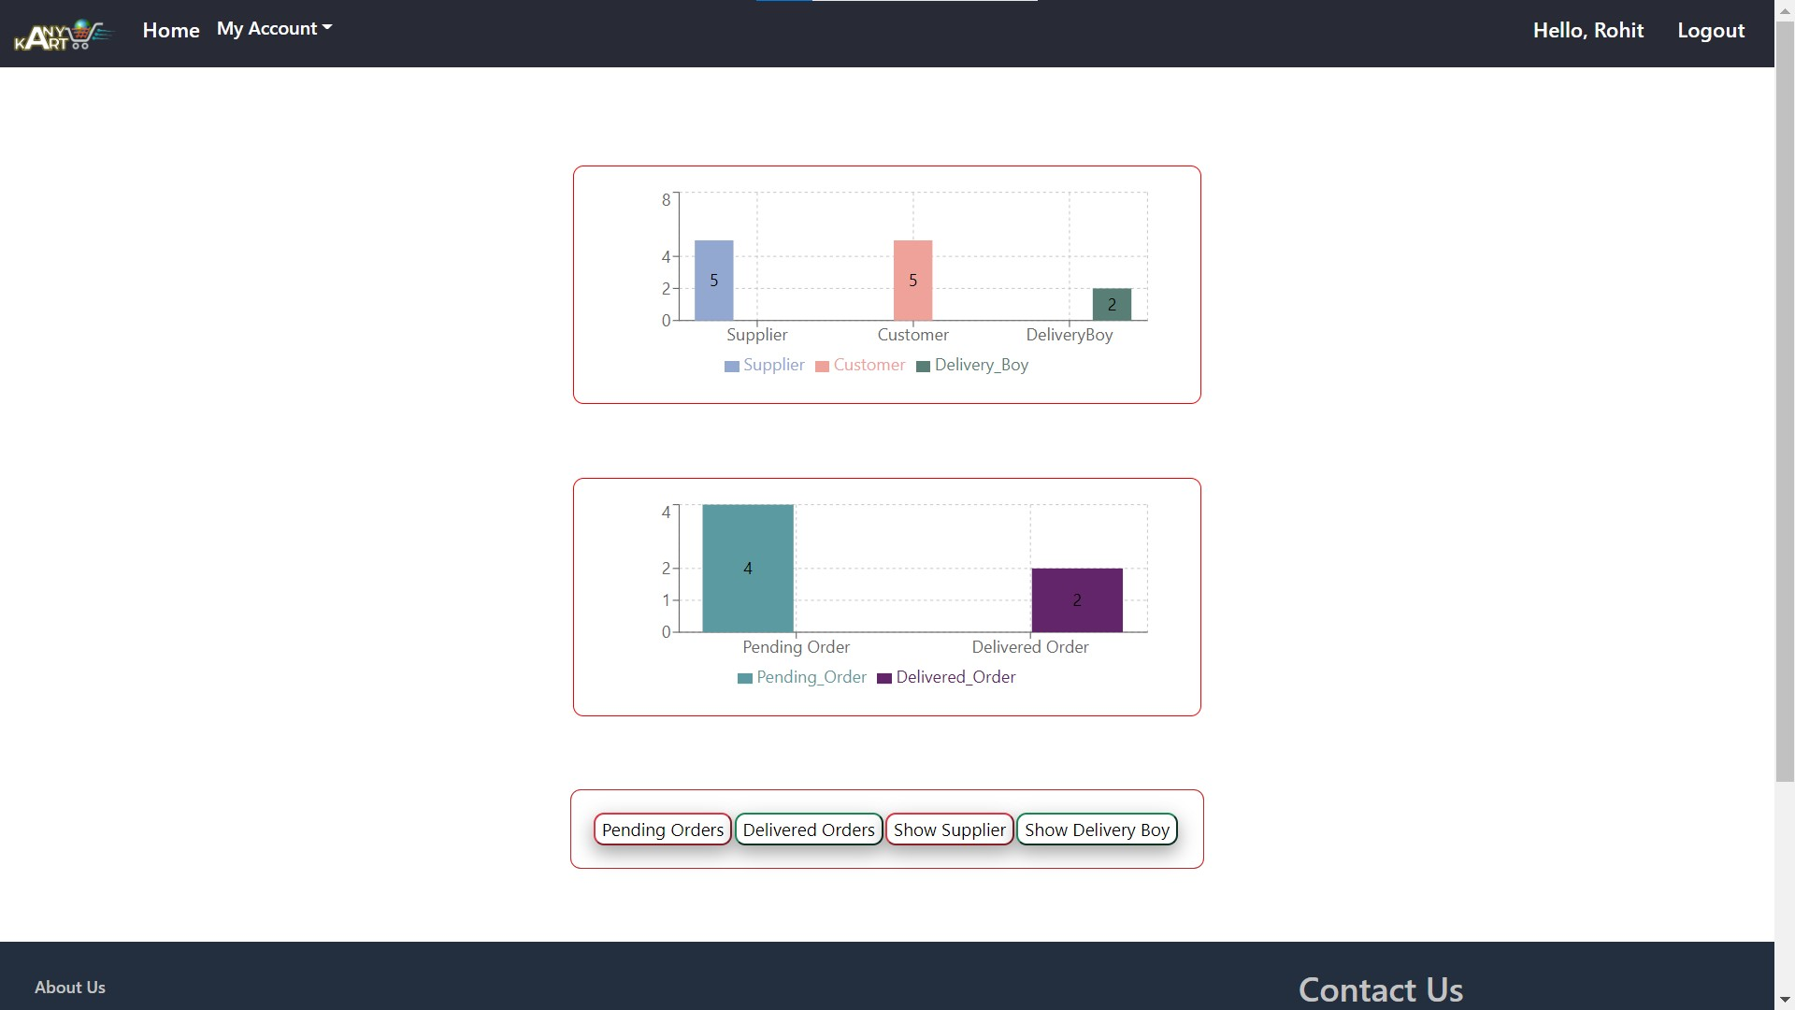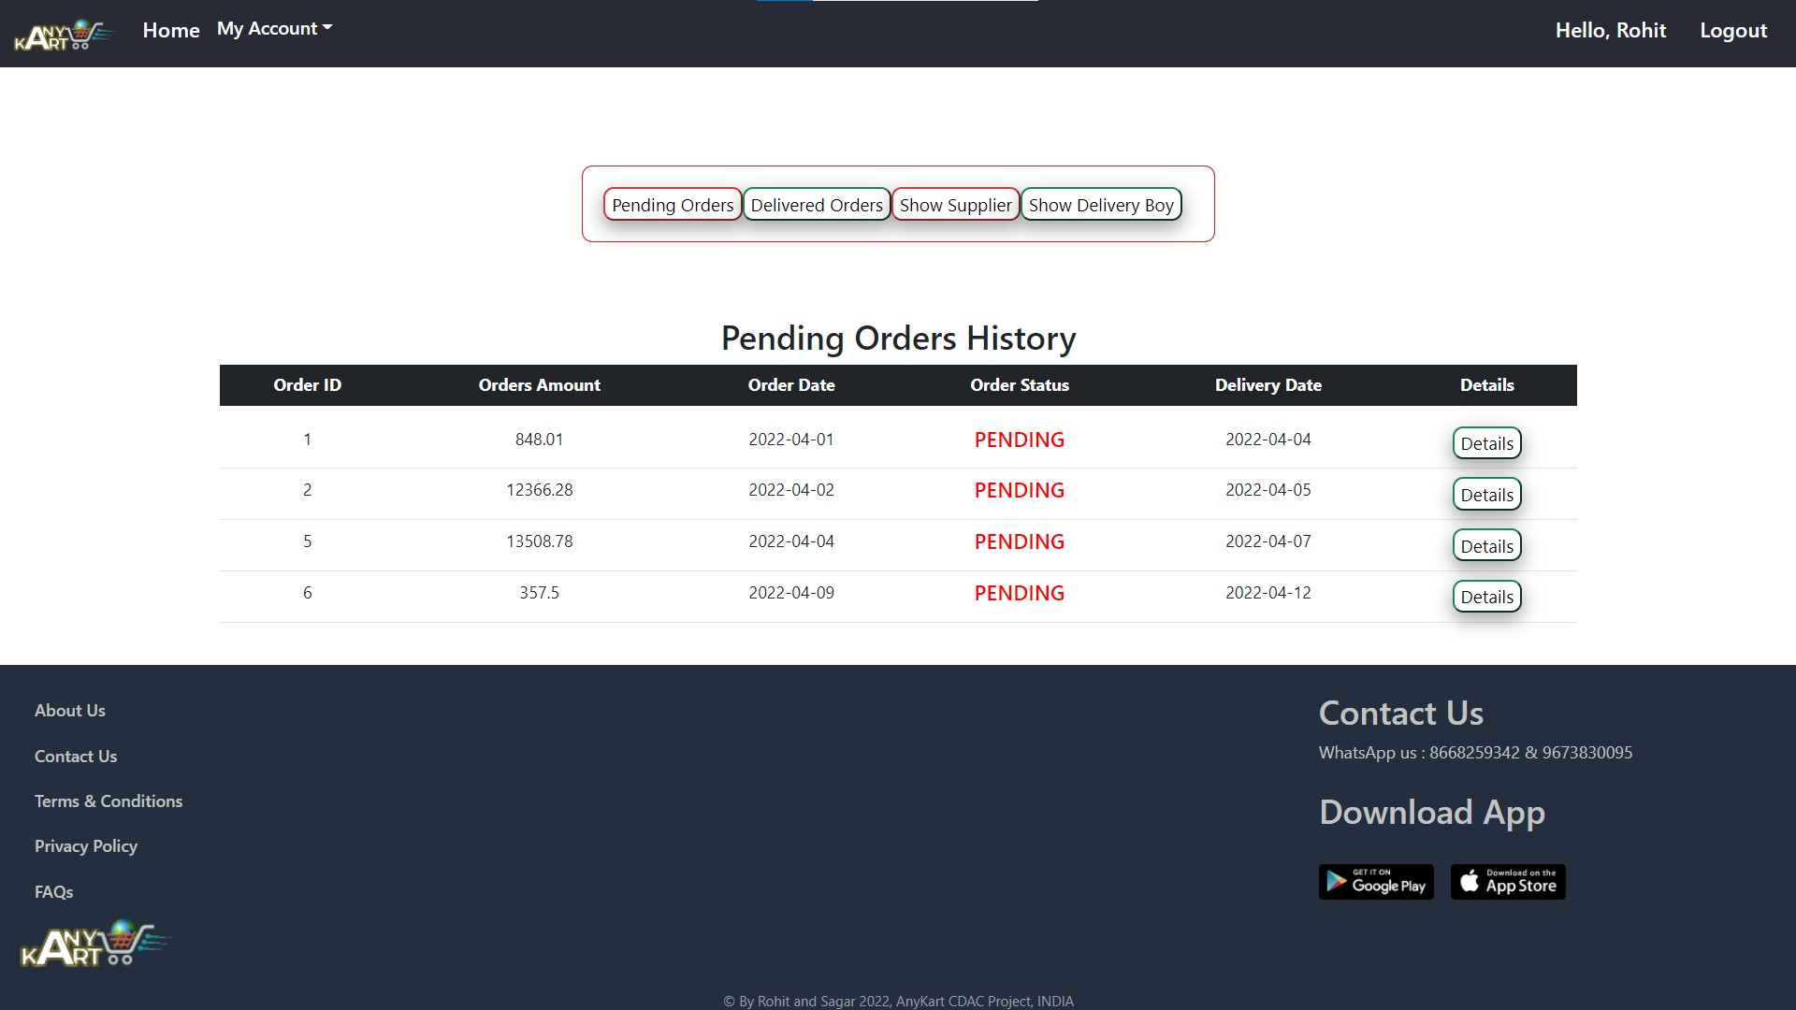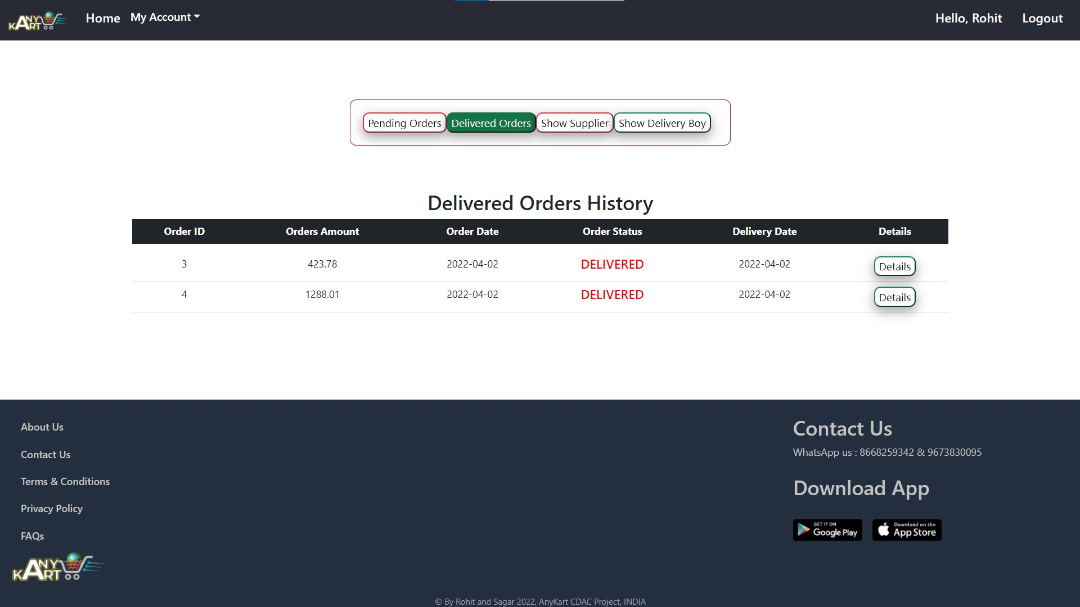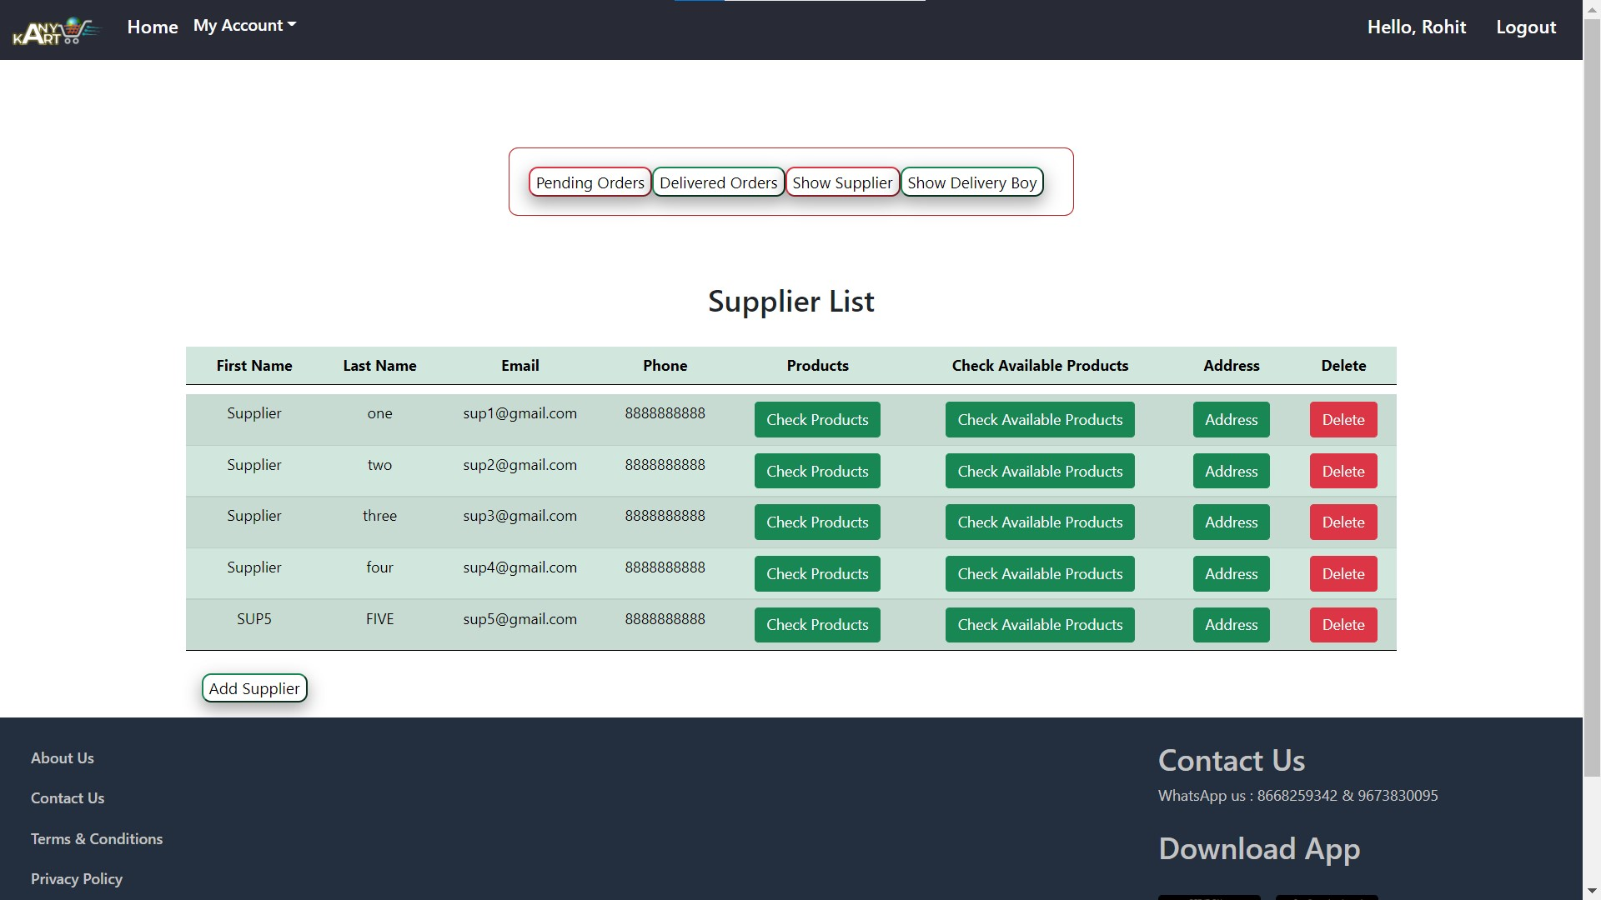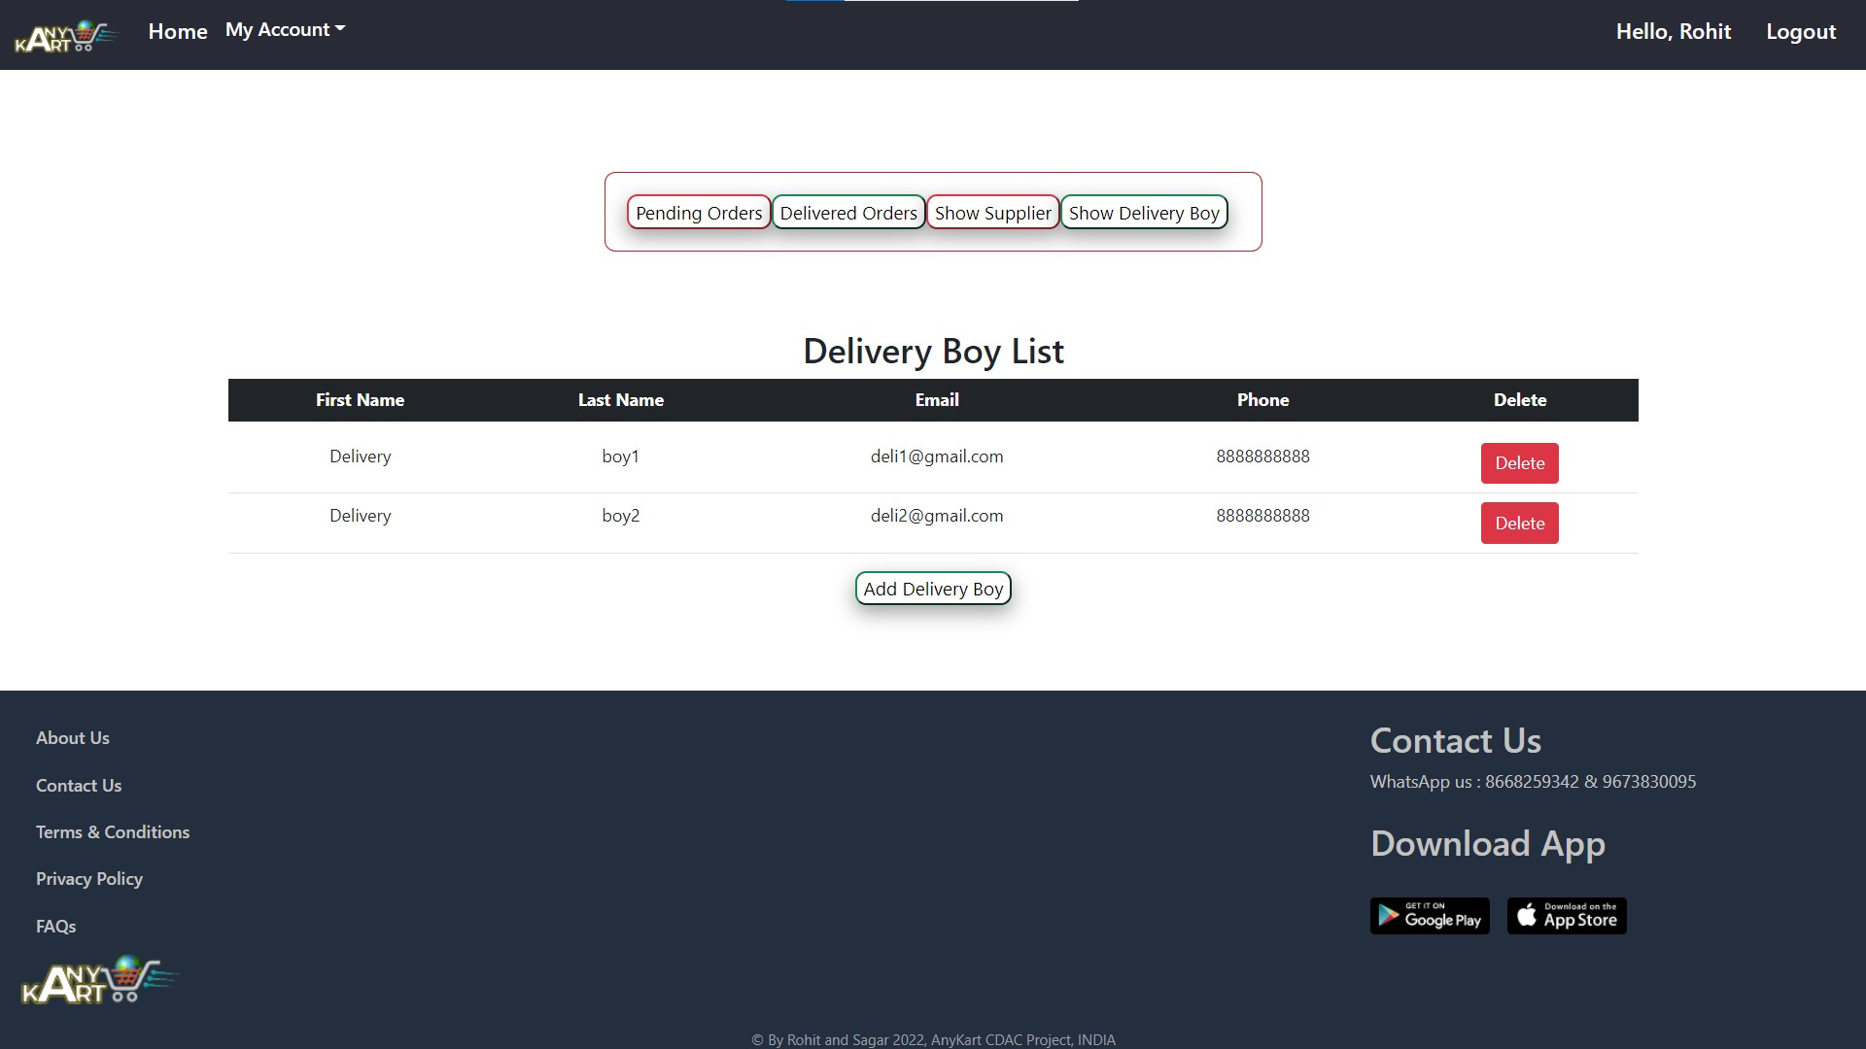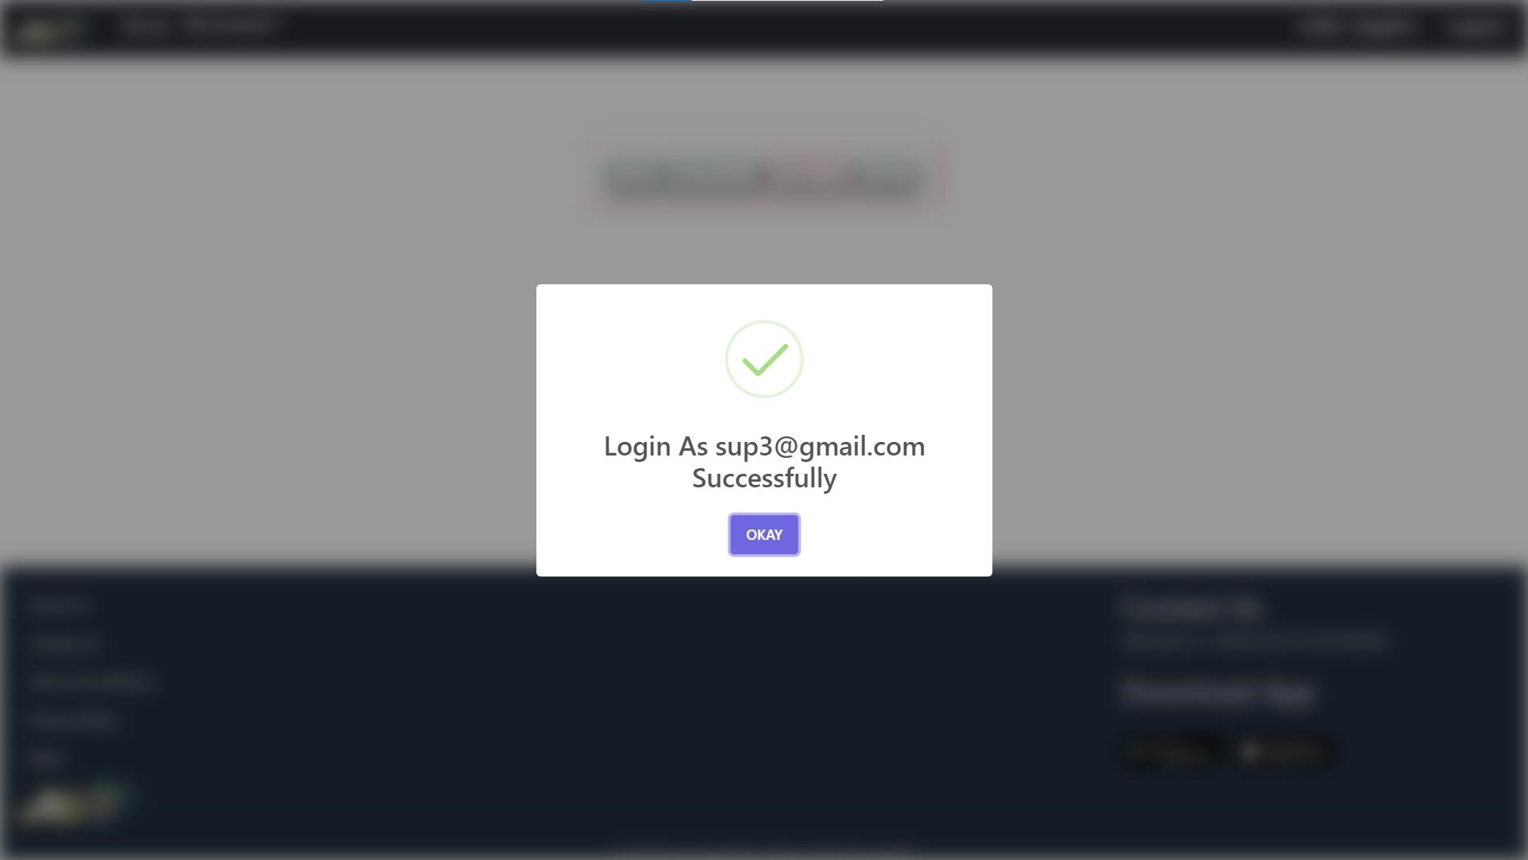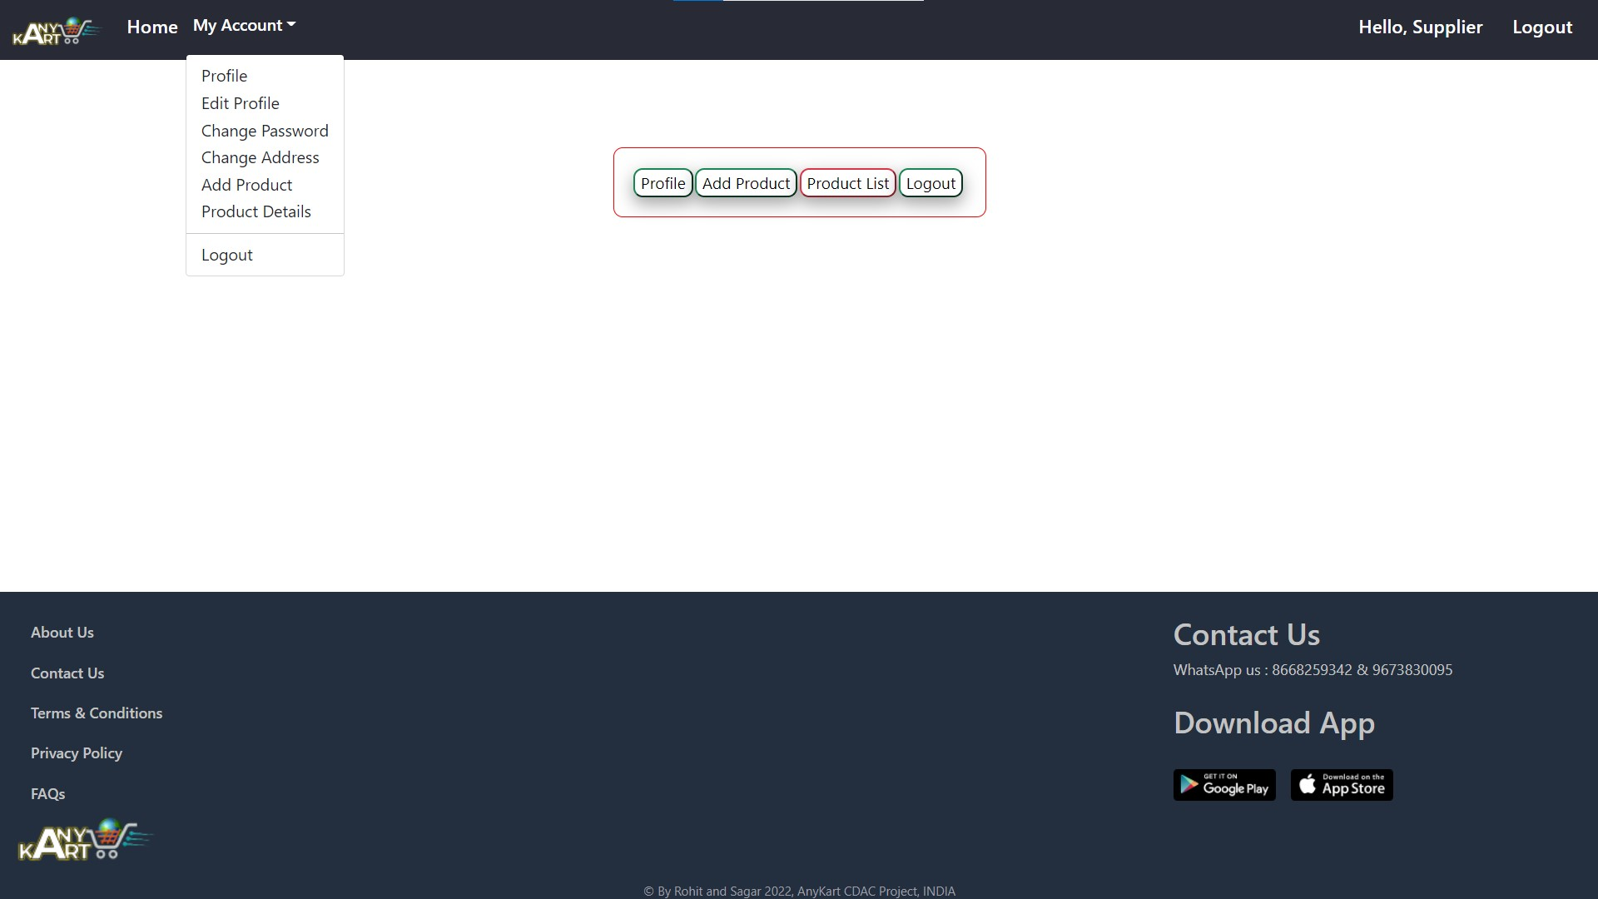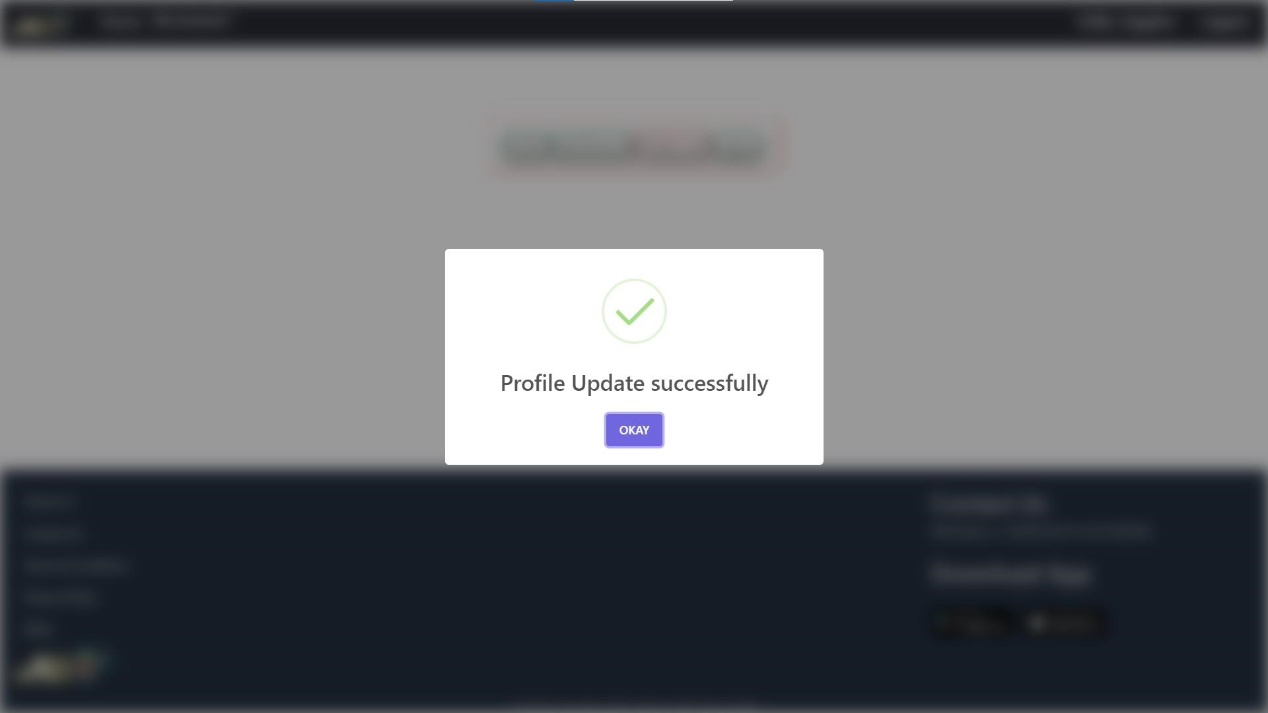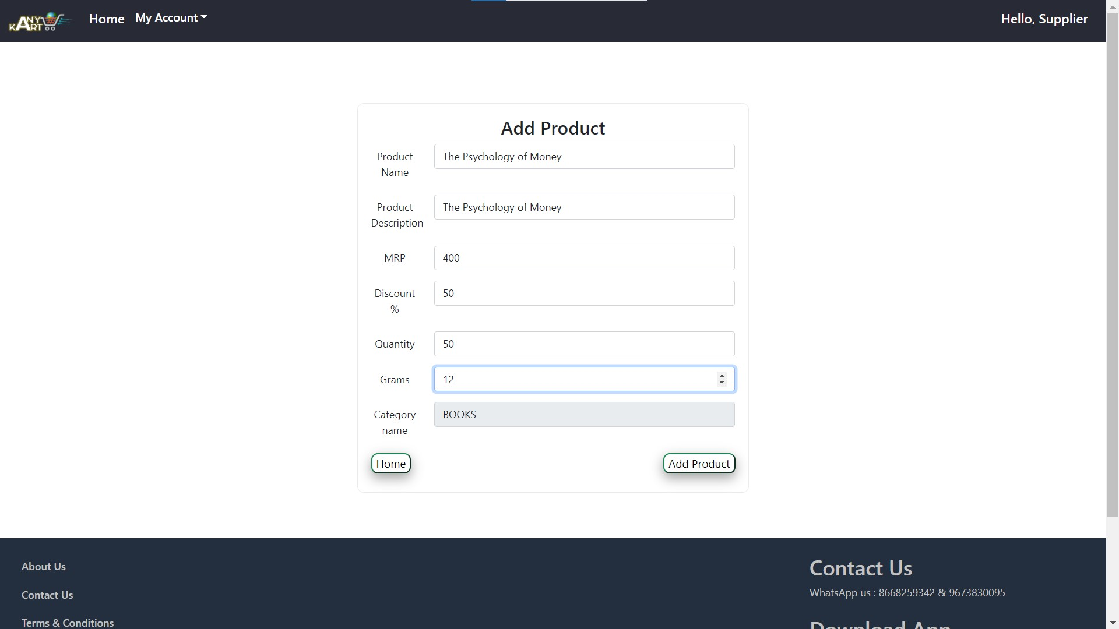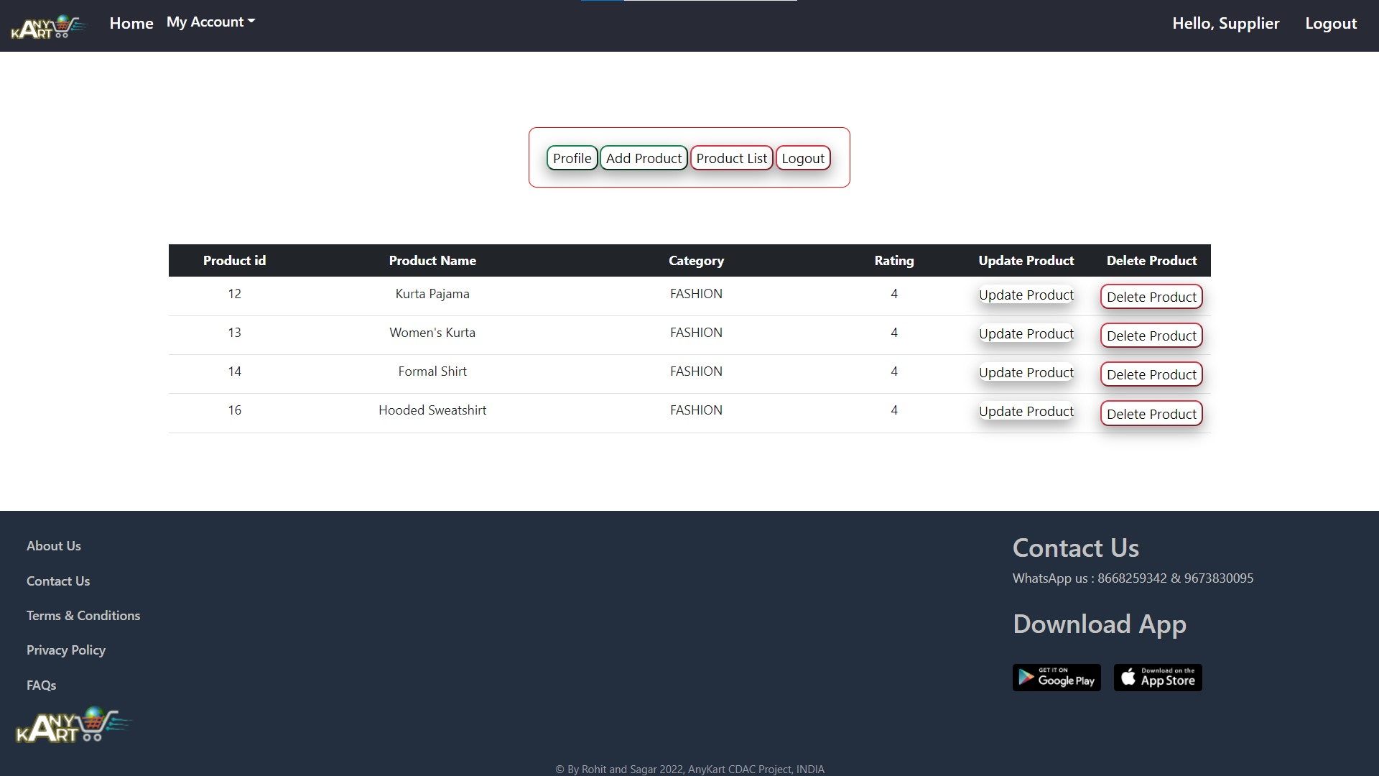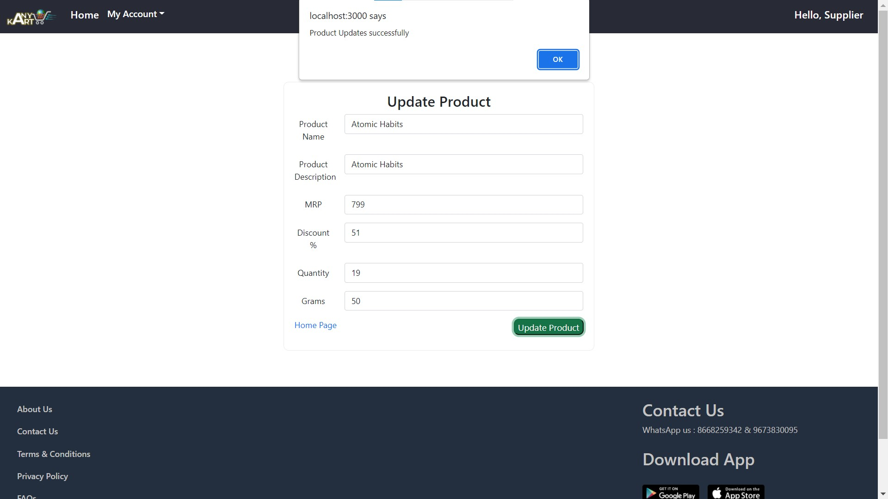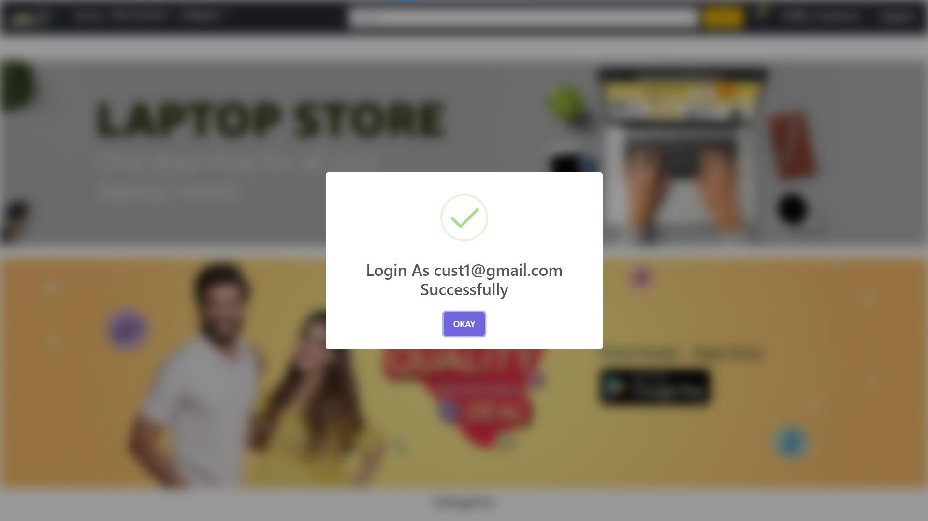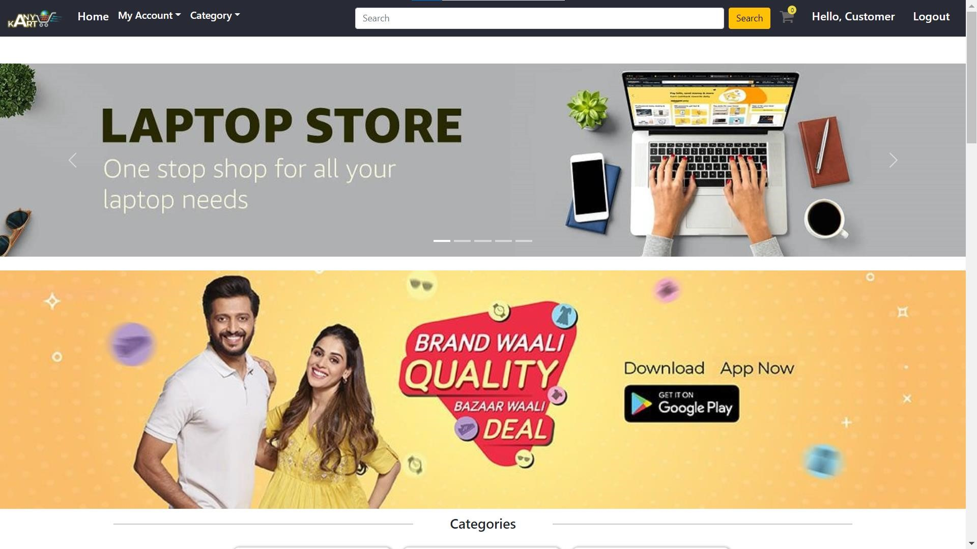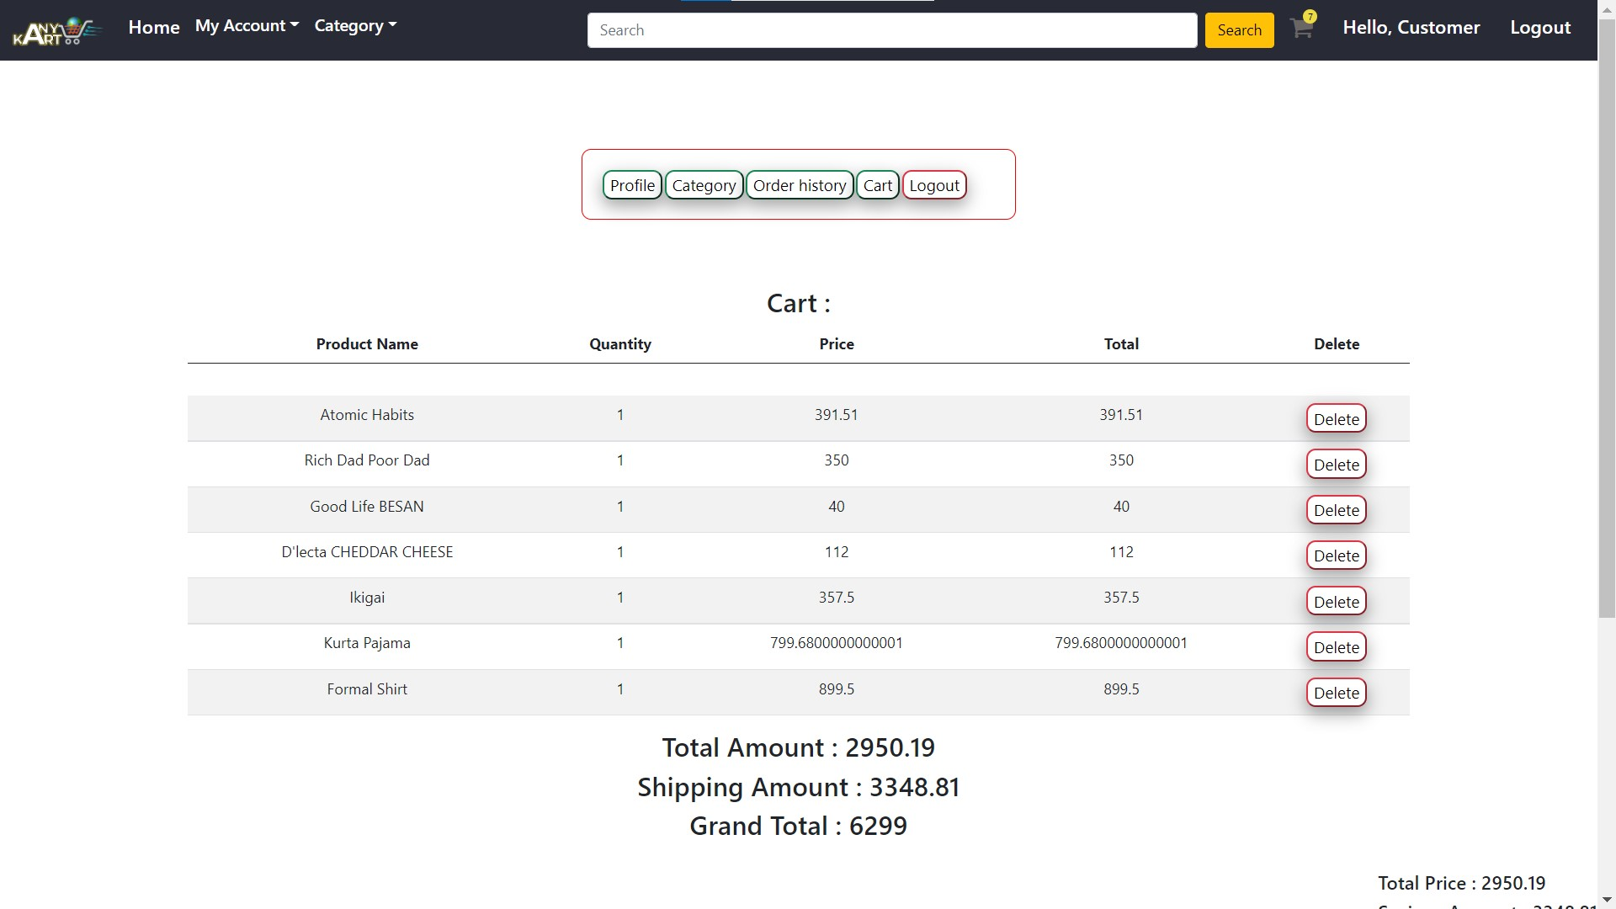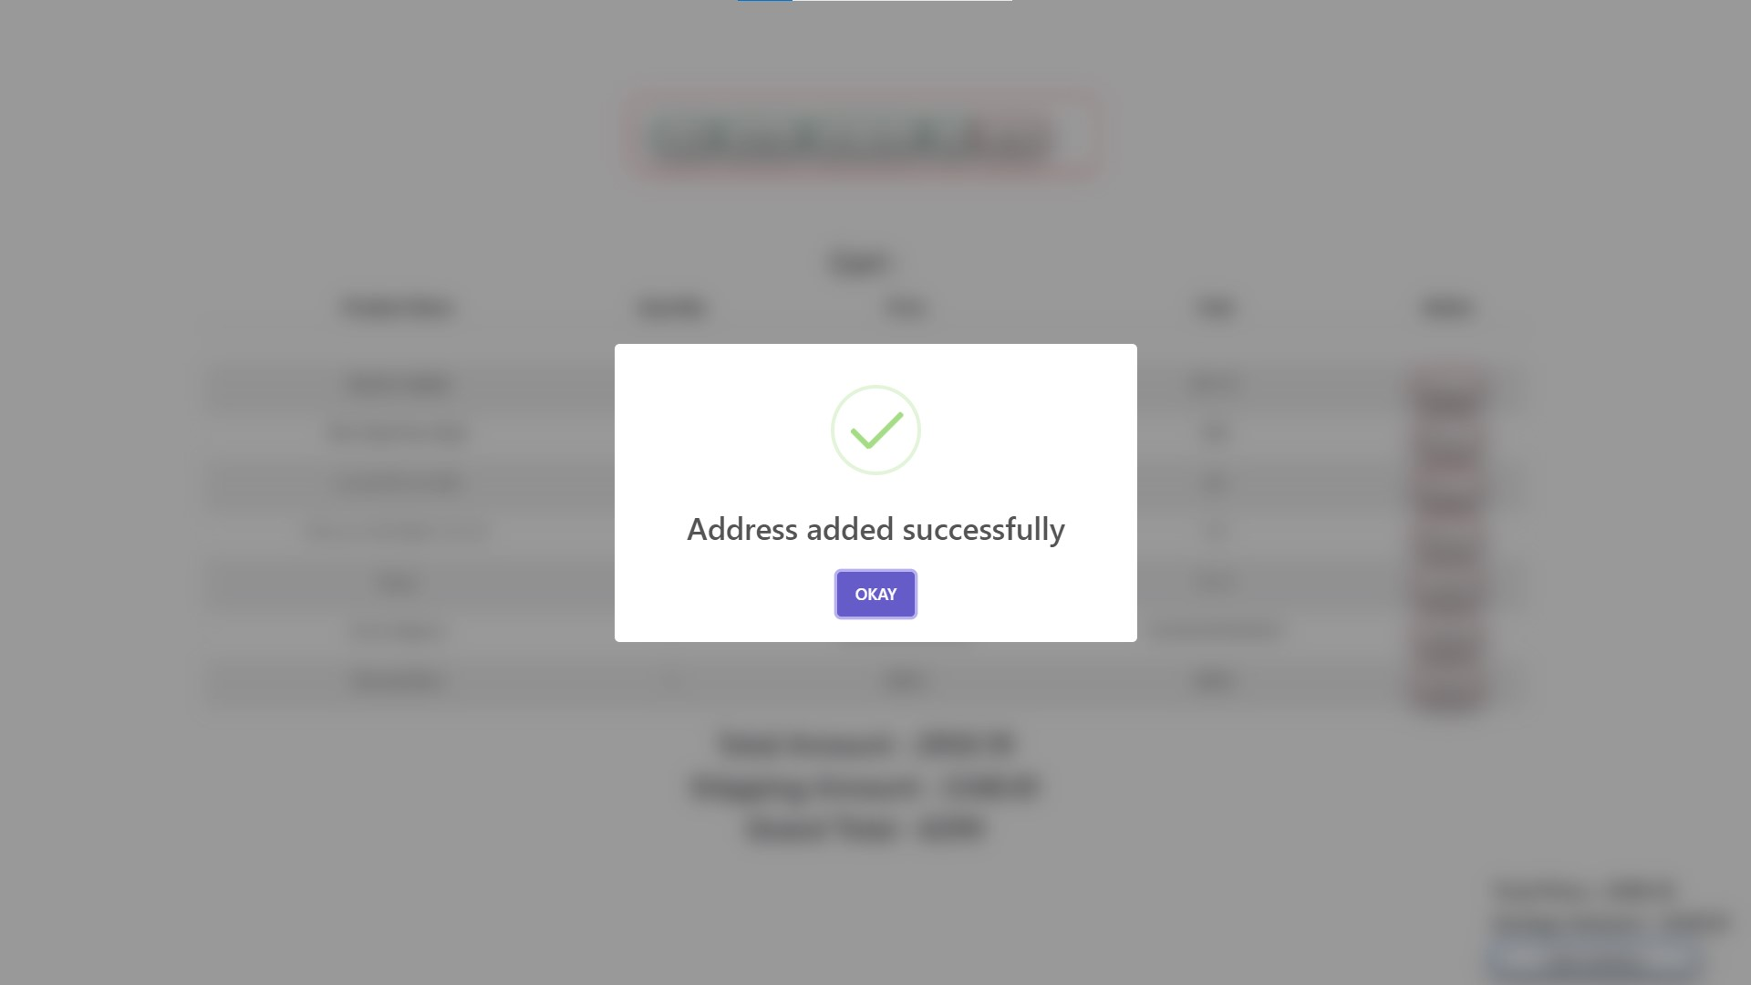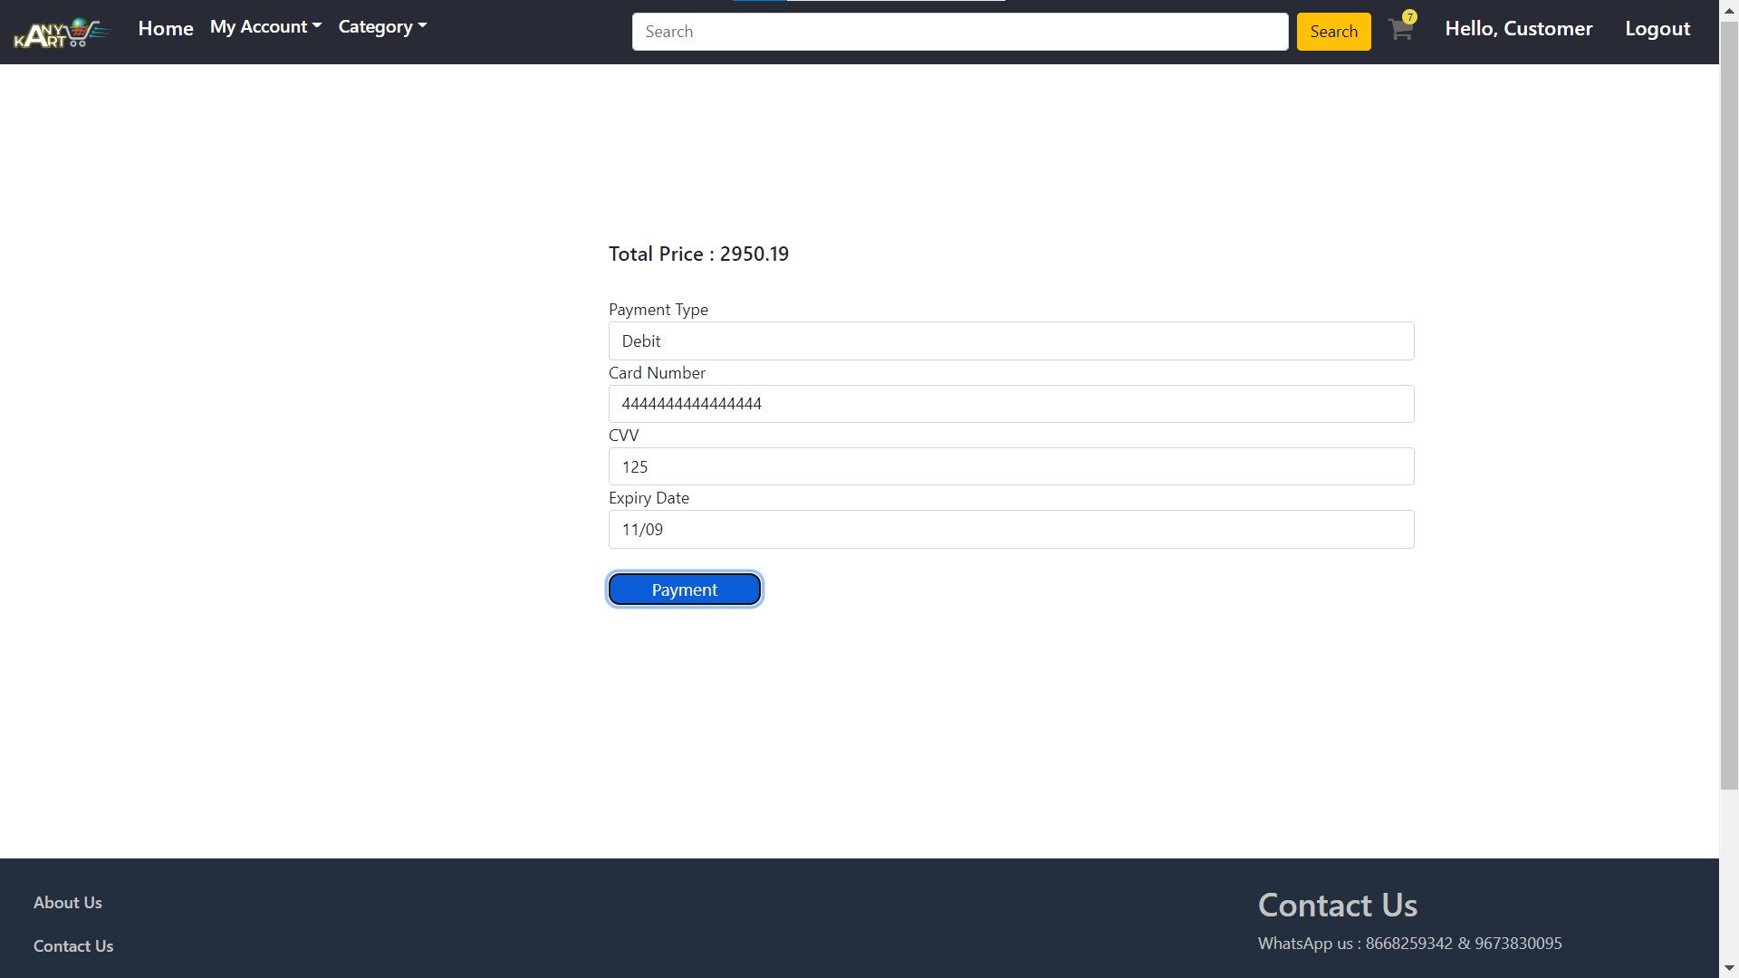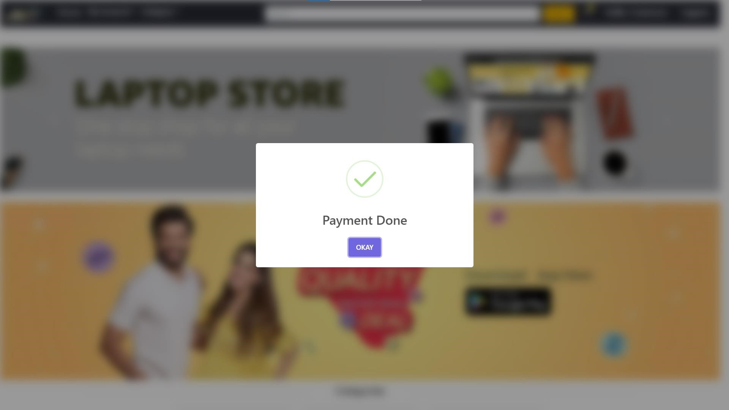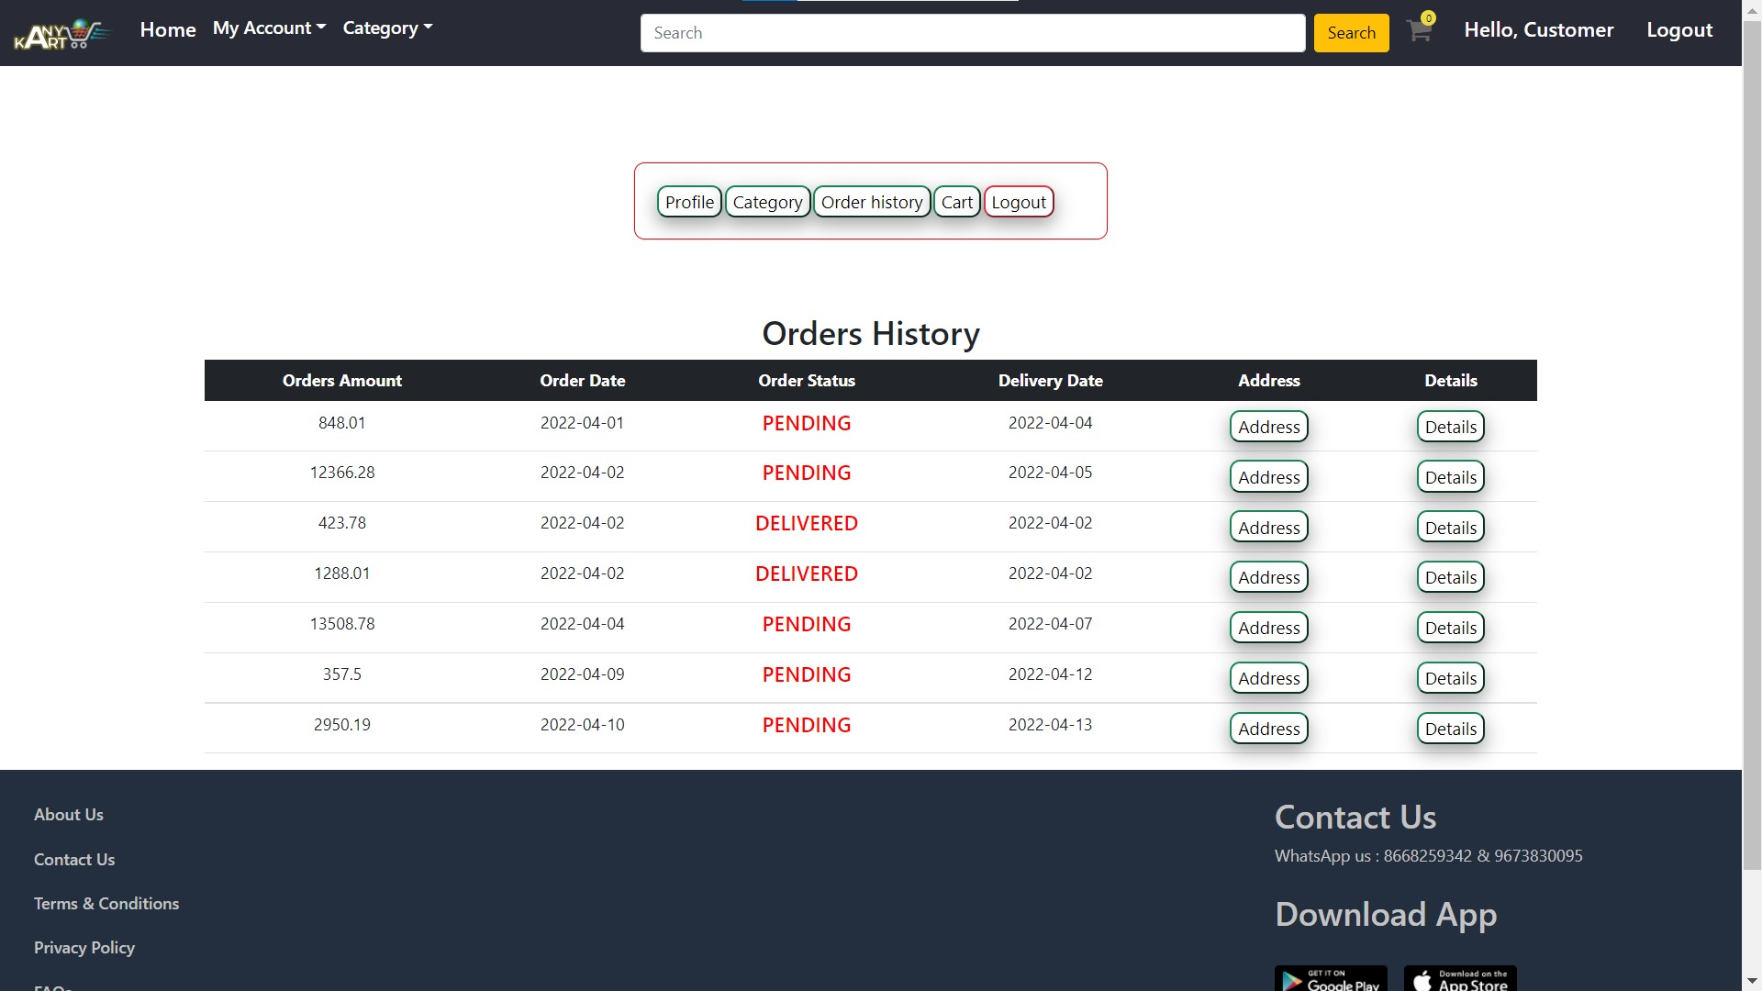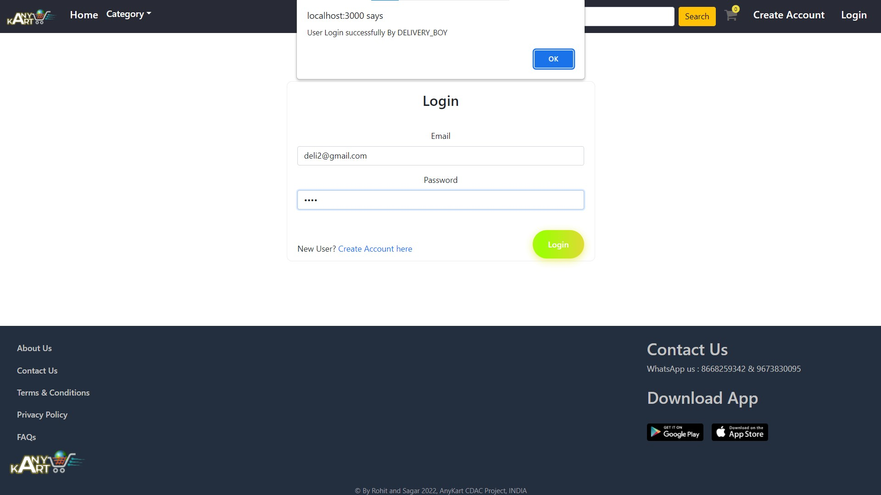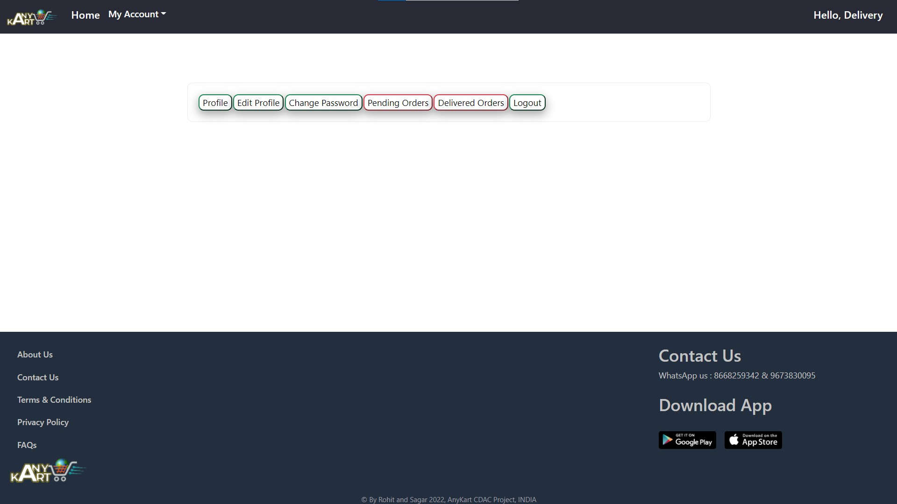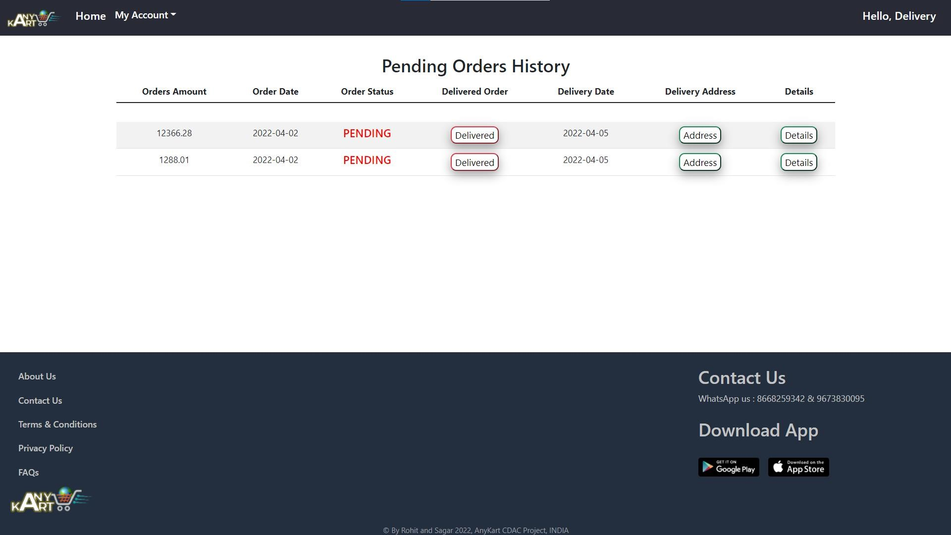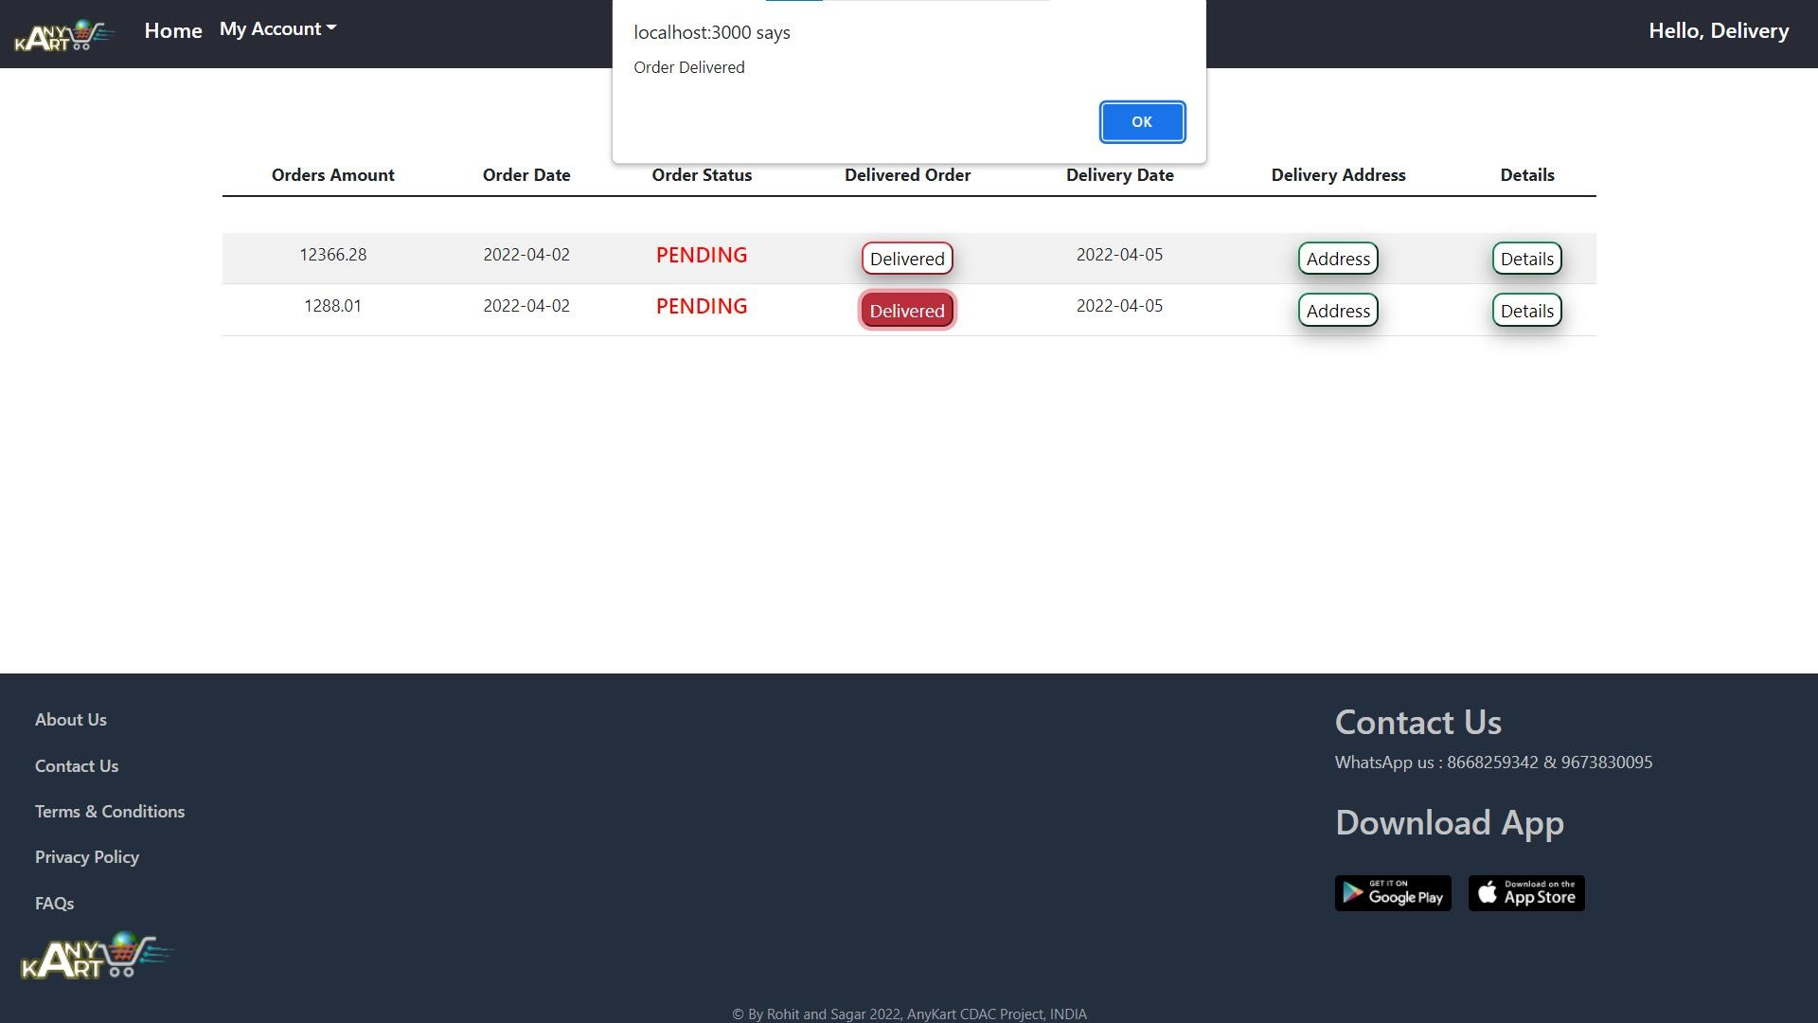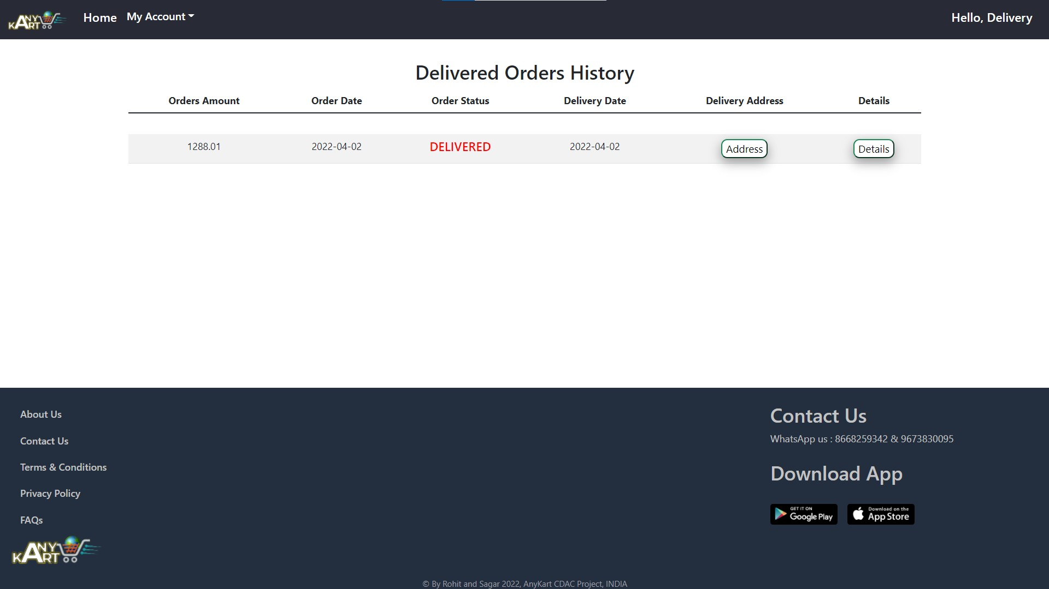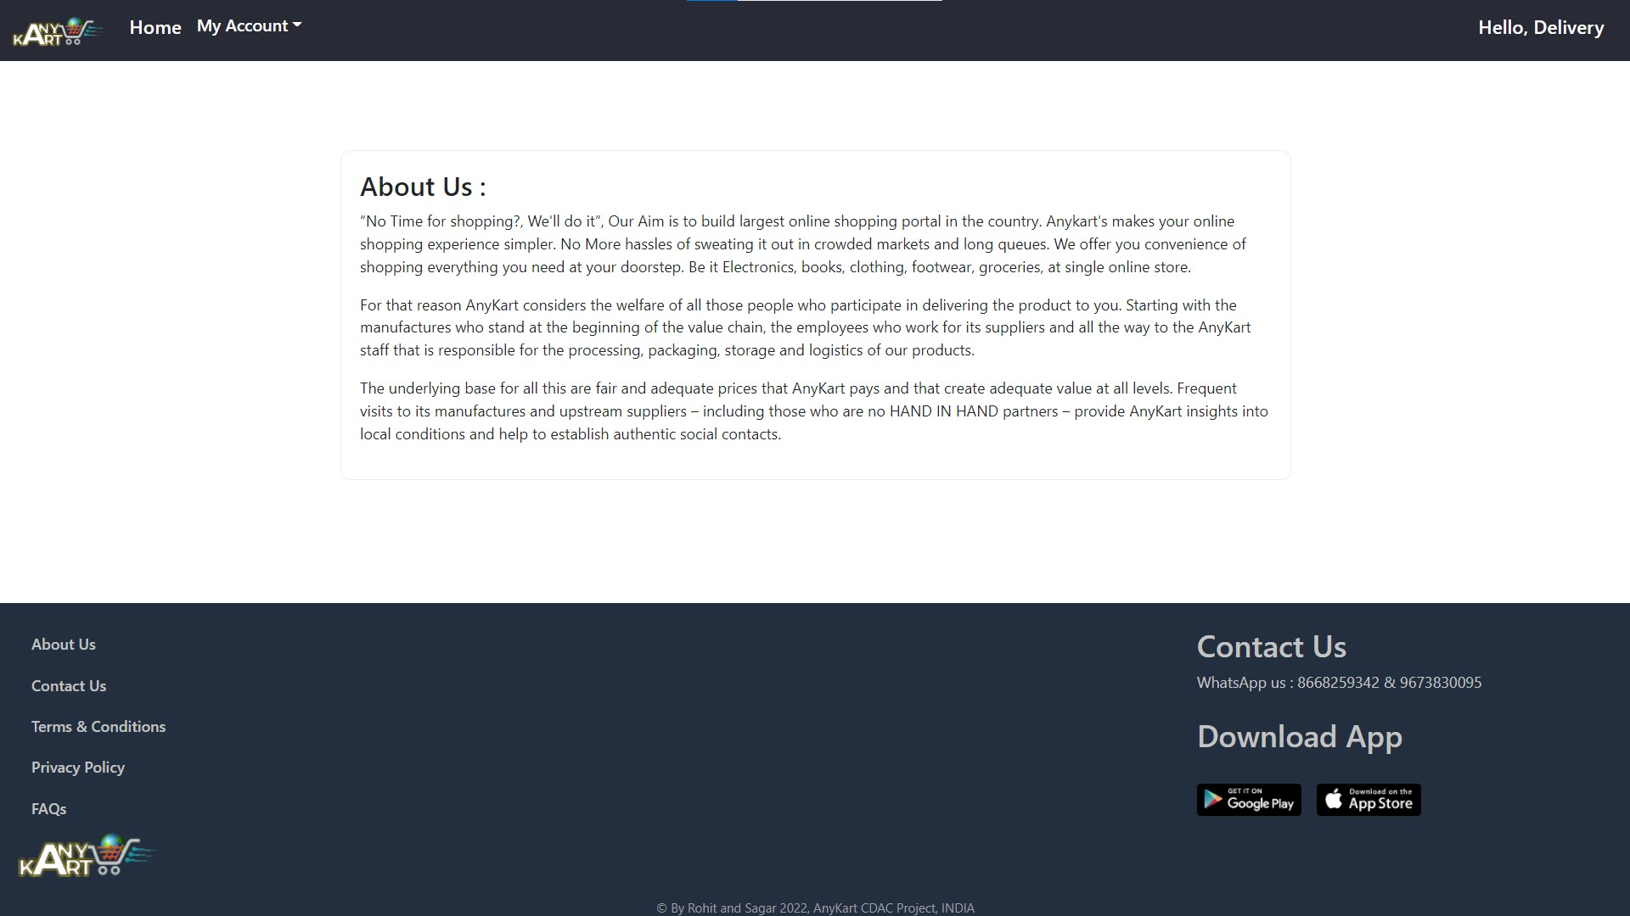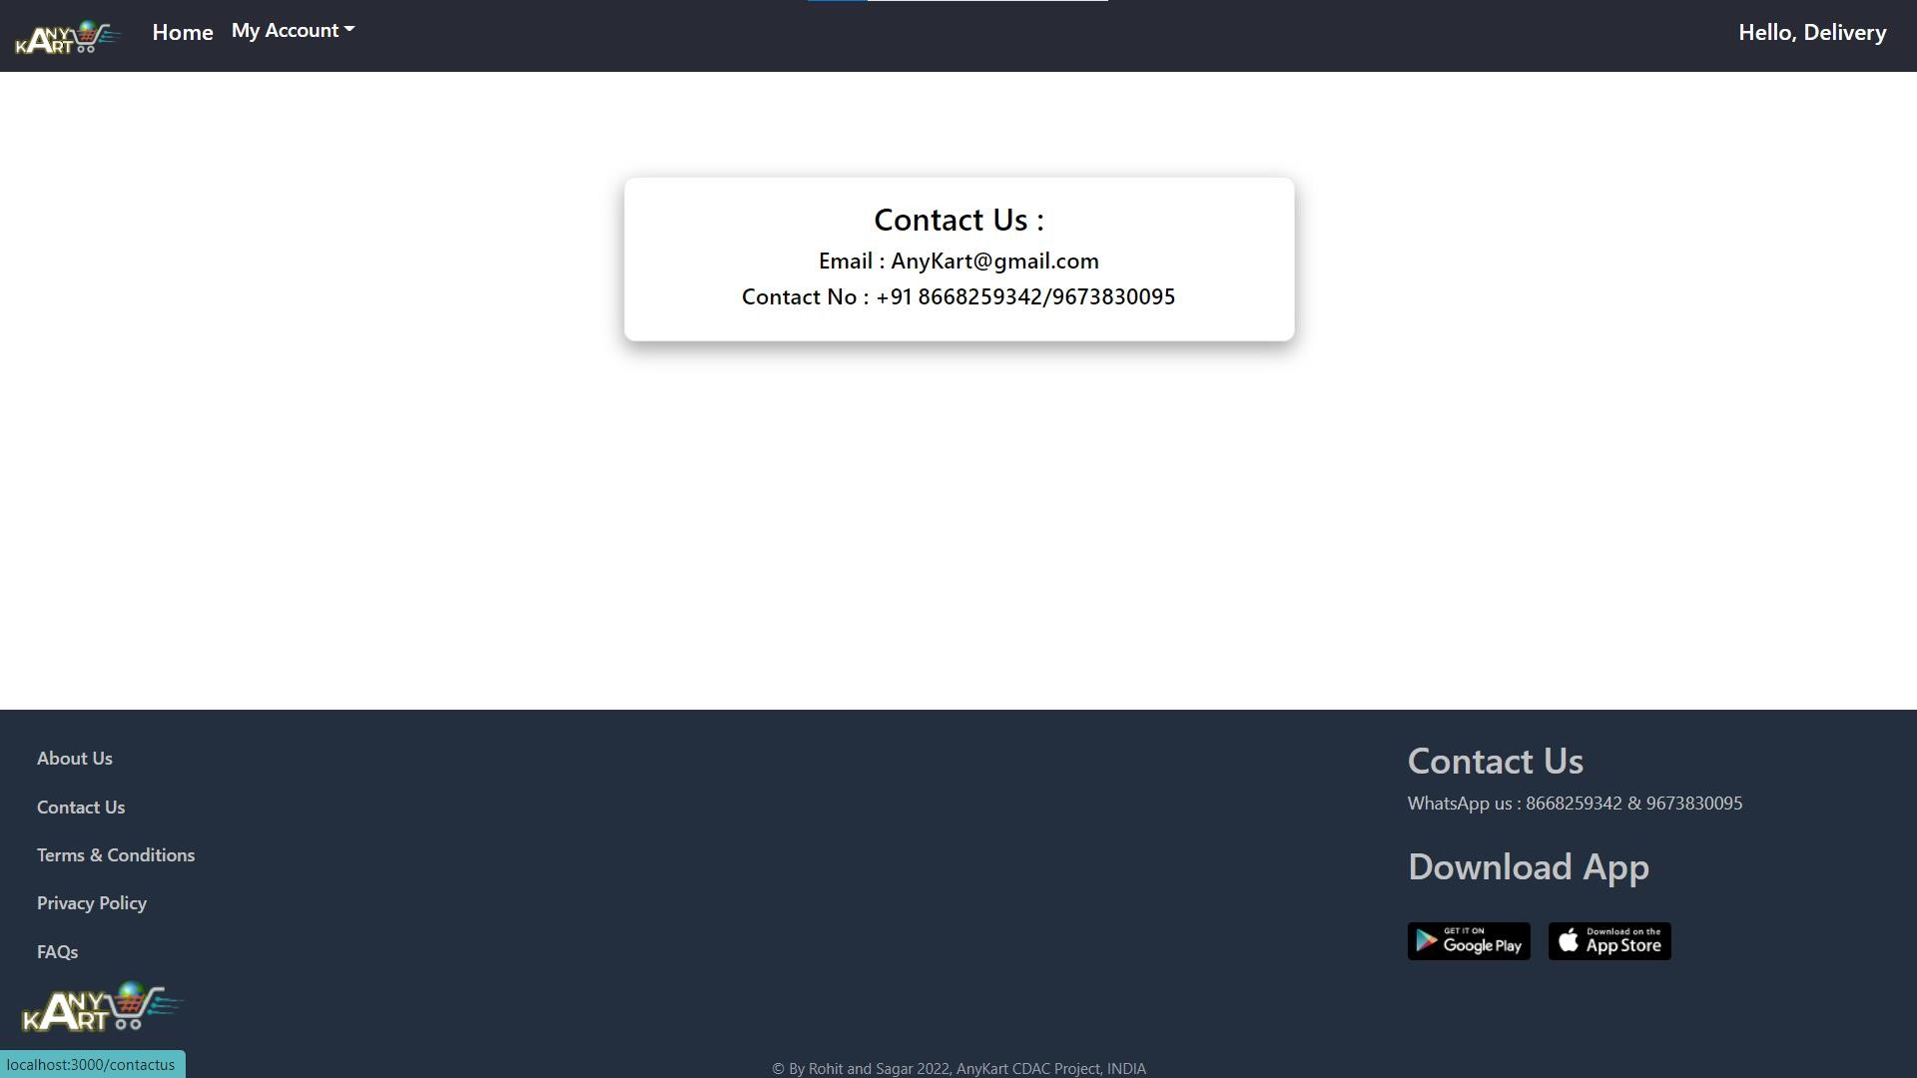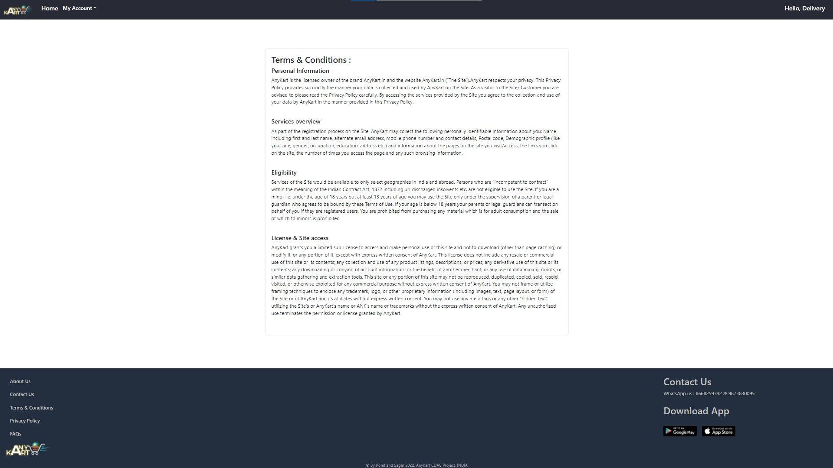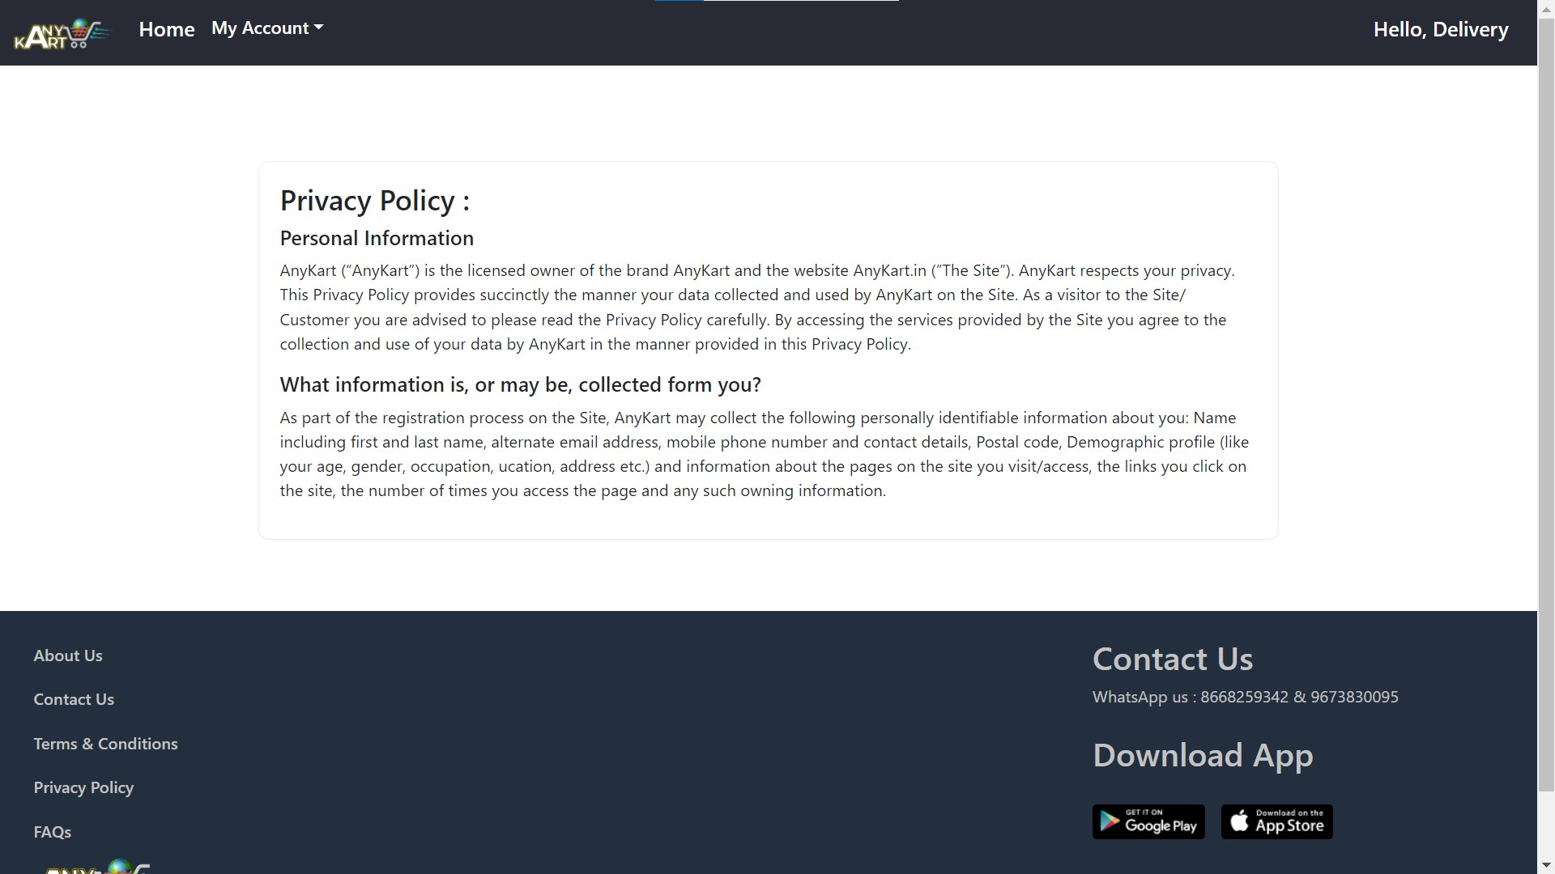

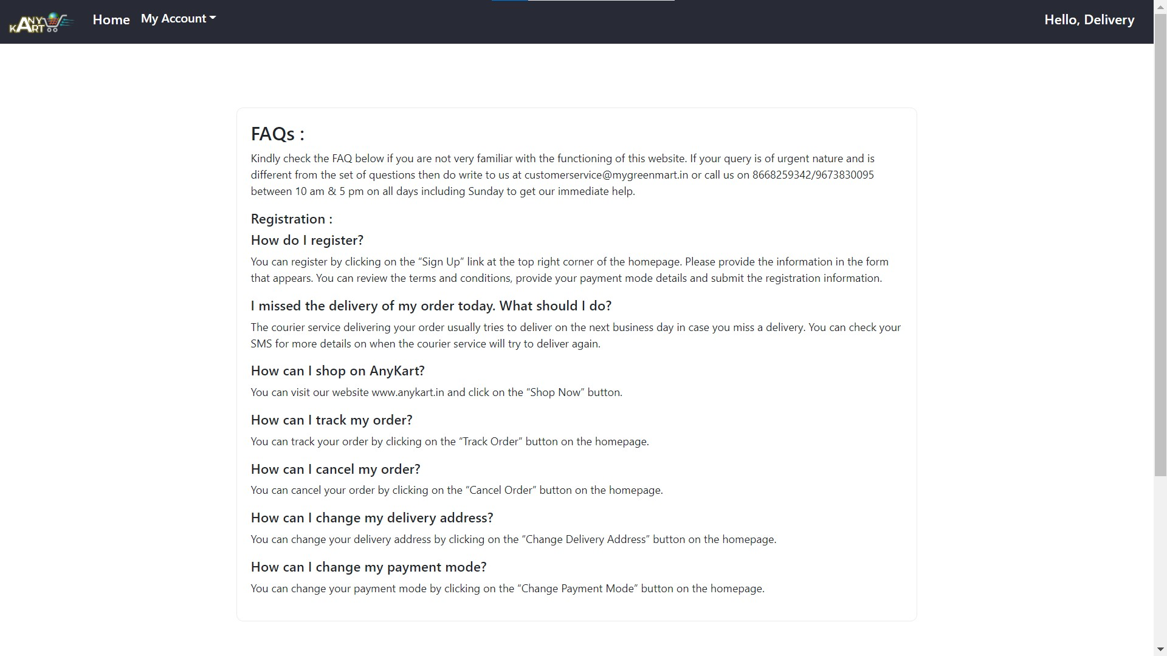

# CONCLUSION

The project entitled **CAR Rental System** was completed successfully.

To create a successful car rental system, it is essential to consider several key factors, including the type of vehicles to be offered, the pricing structure, the availability of vehicles, and the quality of customer service. Additionally, implementing advanced features such as vehicle tracking and automated billing can help improve the efficiency of the rental process and enhance customer satisfaction.

Overall, a well-executed car rental system can provide a valuable service to customers and generate significant revenue for rental companies. With the right design, technology, and customer support, a car rental system can become a trusted and reliable transportation solution for individuals and businesses alike.

# 

# REFERENCES

1. JavaScript Enlightenment, Cody Lindley-First Edition, based on JavaScript 1.5, ECMA-262, Edition
2. Mc Graw Hill’s, Java: The complete reference 7thEdition, Herbert Scheldt

1. Complete CSS Guide, Maxine Sherrin and John Allsopp-O'ReillyMedia; September 2012

**ONLINE REFERENCE**

* 1. [www.Google.com](http://www.google.com/)
  2. [www.w3school.com](http://www.w3school.com/)
  3. [www.javatpoint.com](http://www.javatpoint.com/)